
AMERICAN INTERNATIONAL UNIVERSITY–BANGLADESH
FACULTY OF SCIENCE & TECHNOLOGY
DEPARTMENT OF CSE
INTRODUCTION TO DATABASE
Fall 2022-202 3 Section: I Group: 03

PROJECT NAME
Waste Food Distribution System

Supervised By
MD SAJID BIN-FAISAL

Submitted By

Name | ID
1. AHAMED, MD.SHAFIN | 22-46274-1
2. BISWAS, ESHIKA | 22-46243-1
3.AUSMITA,SUDIPTA SHIKHA | 22-46275-1
4. IQBAL TAMZID | 22-46255-1

Date of Submission: 11/ 12/2022

TABLE OF CONTENTS
COVER PAGE 1
TABLE OF CONTENTS 2
INTRODUCTION 3
SCENARIO 3
ER DIAGRAM 4
Normalization 5-9
FINALIZATION 10
TABLE CREATION 11-22
VALUE INSERT 23-34
QUERY WRITING 35-40
CONCLUSION 40
FUTURE OF CONTAIN 40

INTRODUCTION:
The title of our project is Food Distribution Management System. We have made relational tables to make the database system and the information. We have the description the query that regards to create the tables and insert the values in the rows. We have to go through the normalization process to overcome data insertion, deletion and update anomalies to inside the tables is created. We believe that this project will be beneficial for claim up people’s hunger and save the waste food by distributing.

SCENARIO:
In a waste food distribution System collector gather food from the canteen of educational institutions. The canteen of educational institutions have E.name, E-mail , Date, Address and phone-number. The canteen of educational institutions identified by rank. Many collector gather food from many educational institutions canteen. Collector fetches food from house. House have H-Name, E-mail , House-No, Phone-Number and Address. House is identified by House-No. Many collector fetches food from many houses. Collector pick-up food from programme . Programme have P-Name , Date ,E-mail , Address and Phone-Number. Many collector pick-up food from many programme. Collector take-out food from restaurant. Restaurant have R-Name ,Code ,E-mail ,Phone-Number and Date. Restaurant is identified by Code. Many collectors take-out foods from many restaurants. Collectors accumulates food from guest contributors. Guest contributors have G-Name, E-mail, Address, Date and Phone-Number. Guest contributors identified by Phone-Number. Many collectors accumulates food from many guest contributor. Admin get food from collector and guest contributor. Admin have A-Id, A-Name, Address, E-mail and Phone-Number. Admin is identified by A-Id. Distributors collect food from Admin. Distributors have D-Id, D-Name, Join-Date, Address, E-mail and Phone-Number. Distributors are identified by D-Id. Many distributors collect food from one Admin. Distributors settle-up-with food in hospitals. Hospitals have Ho-Name, Code, Date, Address and Phone-Number. Hospital is identified by Code. Many distributors settle-up-with foods in many hospitals. Distributors serve food in old-age-home. Old-age-home have O-Name, Date, Address, Phone-Number and House-Number. Old-age-home is identified by House-Number. Many distributors serves food in many Old-age-Home. Distributors Give-Payment-To food for orphanage. Orphanage have Or-name, Date, Phone-Number, Address and House-Number. Many distributors Give-Payment-To food in many orphanage . Distributors provide food to street people. Many distributors provides food in many street people. Distributors give food to the workers and worker pays them a little amount. Workers have W-Id, Date, Address, Phone-Number and W-Name. Workers are identified by W-Id. Many distributors distributes foods in many workers. Workers can be specialized into Street-Hawker, Day-Labour and Rickshaw-Puller. Distributors share 5% of profit with the Admin. The service user for claim up people’s hunger and save the waste food by distributing.

ER DIAGRAM:
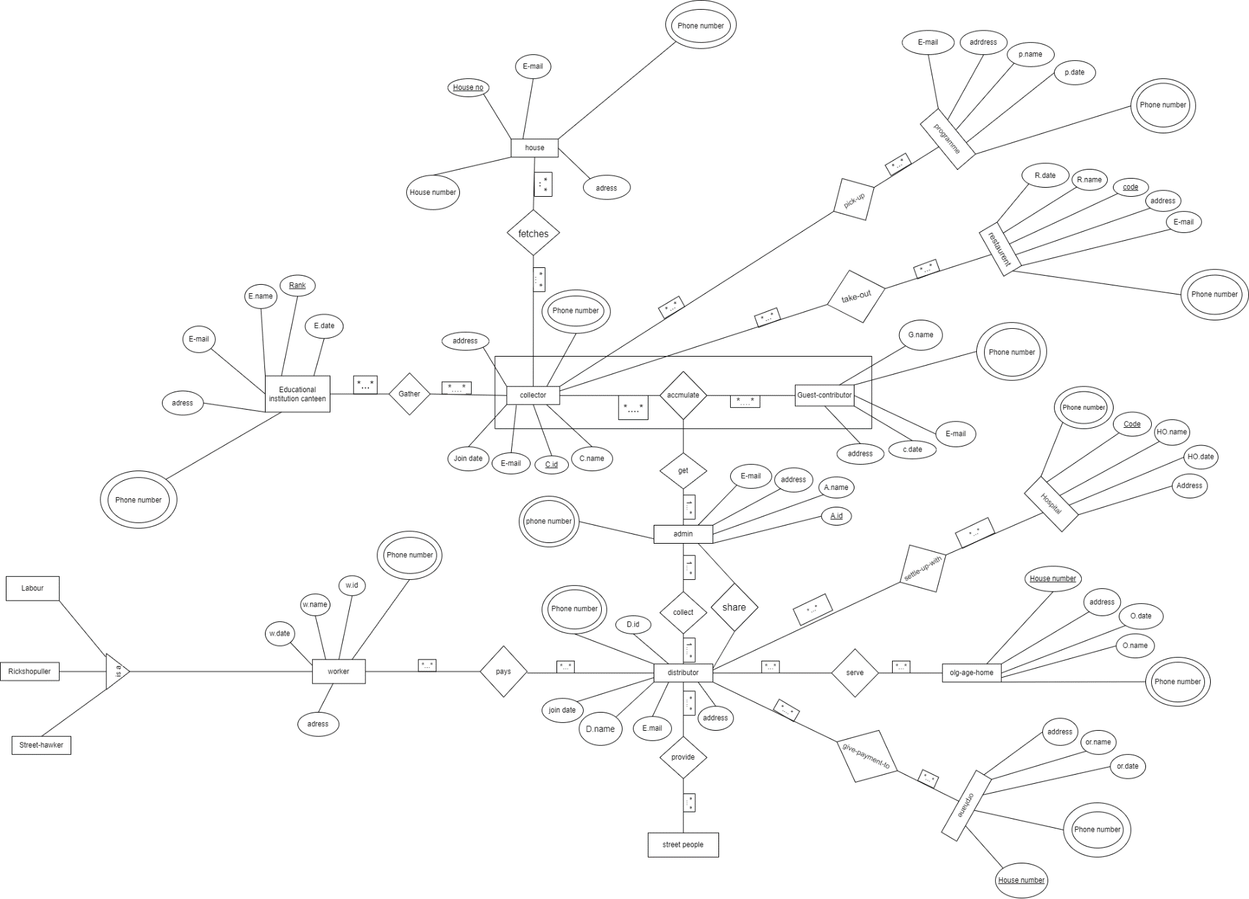

Normalization:
Accmulates:
UNF: C_NAME, C_ID, EMAIL, JOINDATE, ADDRESS, PHONE_NUMBER, G_NAME,
EMAIL, ADDRESS, PHONE_NUMBER, C_DATE
1NF: C_NAME, C_ID, EMAIL, JOINDATE, ADDRESS, PHONE_NUMBER, G_NAME,
EMAIL, ADDRESS, PHONE_NUMBER, C_DATE
2NF: I. C_NAME, C_ID, EMAIL, JOINDATE, ADDRESS, PHONE_NUMBER
PK
II. G_NAME, EMAIL, ADDRESS, PHONE_NUMBER, C_DATE
PK
III. C_ID, PHONE_NUMBER
PK
FK
3NF: SAME AS 2NF
Gets:
UNF: C_NAME, C_ID, EMAIL, JOINDATE, ADDRESS, PHONE_NUMBER, G_NAME,
EMAIL, ADDRESS, PHONE_NUMBER, C_DATE, A_ID, A_NAME, ADDRESS,
EMAIL, PHONE_NUMBER
1NF: C_NAME, C_ID, EMAIL, JOINDATE, ADDRESS, PHONE_NUMBER, G_NAME,
EMAIL, ADDRESS, PHONE_NUMBER, C_DATE, , A_ID, A_NAME, ADDRESS,
EMAIL, PHONE_NUMBER
2NF: I. C_NAME, C_ID, EMAIL, JOINDATE, ADDRESS, PHONE_NUMBER,
PK
G_NAME, EMAIL, ADDRESS, PHONE_NUMBER, C_DATE, A_ID
FK
II. A_ID, A_NAME, ADDRESS, EMAIL, PHONE_NUMBER
PK
3NF: SAME AS 2NF
Collects:
UNF: A_ID, A_NAME, ADDRESS, EMAIL, PHONE_NUMBER, D_ID, D_NAME,
JOINDATE, EMAIL, PHONE_NUMBER, ADDRESS
1NF: A_ID, A_NAME, ADDRESS, EMAIL, PHONE_NUMBER, D_ID, D_NAME,
JOINDATE, EMAIL, PHONE_NUMBER, ADDRESS
2NF: I. A_ID, A_NAME, ADDRESS, EMAIL, PHONE_NUMBER,
PK
II. , D_ID, D_NAME, JOINDATE, EMAIL, PHONE_NUMBER, ADDRESS
PK
III. A_ID, D_ID
PK
FK
3NF: SAME AS 2NF

Share:
UNF: A_ID, A_NAME, ADDRESS, EMAIL, PHONE_NUMBER, D_ID, D_NAME,
JOINDATE, EMAIL, PHONE_NUMBER, ADDRESS
1NF: A_ID, A_NAME, ADDRESS, EMAIL, PHONE_NUMBER, D_ID, D_NAME,
JOINDATE, EMAIL, PHONE_NUMBER, ADDRESS
2NF: I. A_ID, A_NAME, ADDRESS, EMAIL, PHONE_NUMBER,
PK
II. , D_ID, D_NAME, JOINDATE, EMAIL, PHONE_NUMBER, ADDRESS
PK
III. A_ID, D_ID
PK
FK
3NF: SAME AS 2NF
Pays:
UNF: D_ID, D_NAME, JOINDATE, ADDRESS, EMAIL, PHONE_NUMBER, W_ID,
W_NAME, W_DATE, PHONE_NUMBER, ADDRESS
1NF: : D_ID, D_NAME, JOINDATE, ADDRESS, EMAIL, PHONE_NUMBER, W_ID,
W_NAME, W_DATE, PHONE_NUMBER, ADDRESS
2NF: I. D_ID, D_NAME, JOINDATE, ADDRESS, EMAIL, PHONE_NUMBER
PK
II.W_ID, W_NAME, W_DATE, PHONE_NUMBER, ADDRESS
PK
III. D_ID, W_ID
PK
FK
3NF: SAME AS 2NF
Give_payment_to:
UNF: D_ID, D_NAME, JOINDATE, ADDRESS, EMAIL, PHONE_NUMBER,
HOUSE_NUMBER, OR_NAME, OR_DATE, PHONE_NUMBER, ADDRESS
1NF: : D_ID, D_NAME, JOINDATE, ADDRESS, EMAIL, PHONE_NUMBER,
HOUSE_NUMBER, OR_NAME, OR_DATE, PHONE_NUMBER
2NF: I. D_ID, D_NAME, JOINDATE, ADDRESS, EMAIL, PHONE_NUMBER
II. HOUSE_NUMBER, OR_NAME, OR_DATE, PHONE_NUMBER, ADDRESS
III. D_ID, HOUSE_NUMBER
3NF: I. D_ID, D_NAME, JOINDATE, ADDRESS, EMAIL, PHONE_NUMBER
PK
II. HOUSE_NUMBER, OR_NAME, OR_DATE, PHONE_NUMBER, ADDRESS
PK
III. D_ID, HOUSE_NUMBER
PK
FK
IV. HOUSE_NUMBER, ADDRESS
PK

Serves:
UNF: D_ID, D_NAME, JOINDATE, ADDRESS, EMAIL, PHONE_NUMBER,
HOUSE_NUMBER, O_NAME, O_DATE, PHONE_NUMBER, ADDRESS
1NF: : D_ID, D_NAME, JOINDATE, ADDRESS, EMAIL, PHONE_NUMBER,
HOUSE_NUMBER, O_NAME, O_DATE, PHONE_NUMBER
2NF: I. D_ID, D_NAME, JOINDATE, ADDRESS, EMAIL, PHONE_NUMBER
II. HOUSE_NUMBER, O_NAME, O_DATE, PHONE_NUMBER, ADDRESS
III. D_ID, HOUSE_NUMBER
3NF: I. D_ID, D_NAME, JOINDATE, ADDRESS, EMAIL, PHONE_NUMBER
PK
II. HOUSE_NUMBER, O_NAME, O_DATE, PHONE_NUMBER, ADDRESS
PK
III. D_ID, HOUSE_NUMBER
PK
FK
IV. HOUSE_NUMBER, ADDRESS
PK

Take_out:
UNF: C_NAME, C_ID, EMAIL, JOINDATE, ADDRESS, PHONE_NUMBER,
R_NAME, CODE, EMAIL, R_DATE, PHONE_NUMBER, ADDRESS
1NF: : C_NAME, C_ID, EMAIL, JOINDATE, ADDRESS, PHONE_NUMBER,
R_NAME, CODE, EMAIL, R_DATE, PHONE_NUMBER, ADDRESS

2NF: I. C_NAME, C_ID, EMAIL, JOINDATE, ADDRESS, PHONE_NUMBER
II. R_NAME, CODE, EMAIL, R_DATE, PHONE_NUMBER, ADDRESS
III. C_ID, CODE
3NF: I. C_NAME, C_ID, EMAIL, JOINDATE, ADDRESS, PHONE_NUMBER
PK
II.R_NAME, CODE, EMAIL, R_DATE, PHONE_NUMBER, ADDRESS
PK
III. C_ID, CODE
PK
FK
IV. CODE, ADDRESS
PK

Settle_up_with:
UNF: D_ID, D_NAME, JOINDATE, ADDRESS, EMAIL, PHONE_NUMBER,
HO_NAME, CODE, HO_DATE, PHONE_NUMBER, ADDRESS
1NF: : D_ID, D_NAME, JOINDATE, ADDRESS, EMAIL, PHONE_NUMBER,
HO_NAME, CODE, HO_DATE, PHONE_NUMBER, ADDRESS
2NF: I. D_ID, D_NAME, JOINDATE, ADDRESS, EMAIL, PHONE_NUMBER
PK
II. HO_NAME, CODE, HO_DATE, PHONE_NUMBER, ADDRESS
PK
III. D_ID, CODE
PK
FK
3NF: SAME AS 2NFW

Pick_up:
UNF: C_NAME, C_ID, EMAIL, JOINDATE, ADDRESS, PHONE_NUMBER, P_NAME,
EMAIL, ADDRESS, PHONE_NUMBER, P_DATE
1NF: C_NAME, C_ID, EMAIL, JOINDATE, ADDRESS, PHONE_NUMBER, P_NAME,
EMAIL, ADDRESS, PHONE_NUMBER, P_DATE
2NF: I. C_NAME, C_ID, EMAIL, JOINDATE, ADDRESS, PHONE_NUMBER
PK
II. P_NAME, EMAIL, ADDRESS, PHONE_NUMBER, P_DATE
PK
III. C_ID, PHONE_NUMBER
PK
FK
3NF: SAME AS 2NF
Gather:
UNF: C_NAME, C_ID, EMAIL, JOINDATE, ADDRESS, PHONE_NUMBER, E_NAME,
RANK, EMAIL, ADDRESS, PHONE_NUMBER, E_DATE
1NF: C_NAME, C_ID, EMAIL, JOINDATE, ADDRESS, PHONE_NUMBER, E_NAME,
RANK, EMAIL, ADDRESS, PHONE_NUMBER, E_DATE
2NF: I. C_NAME, C_ID, EMAIL, JOINDATE, ADDRESS, PHONE_NUMBER
PK
II. E_NAME, RANK, EMAIL, ADDRESS, PHONE_NUMBER, E_DATE
PK
III. C_ID, RANK
PK
FK
3NF: SAME AS 2NF

Fetches:
UNF: C_NAME, C_ID, EMAIL, JOINDATE, ADDRESS, PHONE_NUMBER,
HOUSE_NO, H_NAME, EMAIL, PHONE_NUMBER, ADDRESS
1NF: C_NAME, C_ID, EMAIL, JOINDATE, ADDRESS, PHONE_NUMBER,
HOUSE_NO, H_NAME, EMAIL, PHONE_NUMBER
2NF: I. C_NAME, C_ID, EMAIL, JOINDATE, ADDRESS, PHONE_NUMBER
II. HOUSE_NO, H_NAME, EMAIL, PHONE_NUMBER
III. C_ID, HOUSE_NO
3NF: : I. C_NAME, C_ID, EMAIL, JOINDATE, ADDRESS, PHONE_NUMBER
PK
II. HOUSE_NO, H_NAME, EMAIL, PHONE_NUMBER
PK
III. C_ID, HOUSE_NO
PK
FK
IV. HOUSE_NO, ADDRESS
PK

FINALIZATION:
- C_NAME, C_ID, EMAIL, JOINDATE, ADDRESS, PHONE_NUMBER
- G_NAME, EMAIL, ADDRESS, PHONE_NUMBER, C_DATE
PK
- C_ID, PHONE_NUMBER
PK
FK
- . C_NAME, C_ID, EMAIL, JOINDATE, ADDRESS, PHONE_NUMBER,
PK
G_NAME, EMAIL, C_DATE, A_ID
FK
- A_ID, A_NAME, ADDRESS, EMAIL, PHONE_NUMBER
PK
- D_ID, D_NAME, JOINDATE, EMAIL, PHONE_NUMBER, ADDRESS
PK
- A_ID, D_ID
FK
PK

- W_ID, W_NAME, W_DATE, PHONE_NUMBER, ADDRESS
PK

- D_ID, W_ID
PK
FK

- HOUSE_NUMBER, OR_NAME, OR_DATE, PHONE_NUMBER, ADDRESS
PK

- D_ID, HOUSE_NUMBER
PK
FK

- HOUSE_NUMBER, ADDRESS
PK

- HOUSE_NUMBER, O_NAME, O_DATE, PHONE_NUMBER, ADDRESS
PK

- HO_NAME, CODE, HO_DATE, PHONE_NUMBER, ADDRESS
PK

- D_ID, CODE
PK
FK

- R_NAME, CODE, EMAIL, R_DATE, PHONE_NUMBER, ADDRESS
PK

- C_ID, CODE
PK
FK

- CODE, ADDRESS
PK

- P_NAME, EMAIL, ADDRESS, PHONE_NUMBER, P_DATE
PK

- E_NAME, RANK, EMAIL, ADDRESS, PHONE_NUMBER, E_DATE
PK

- C_ID, RANK
PK
FK

- HOUSE_NO, H_NAME, EMAIL, PHONE_NUMBER
PK

- C_ID, HOUSE_NO
PK
FK

TABLE CREATION:
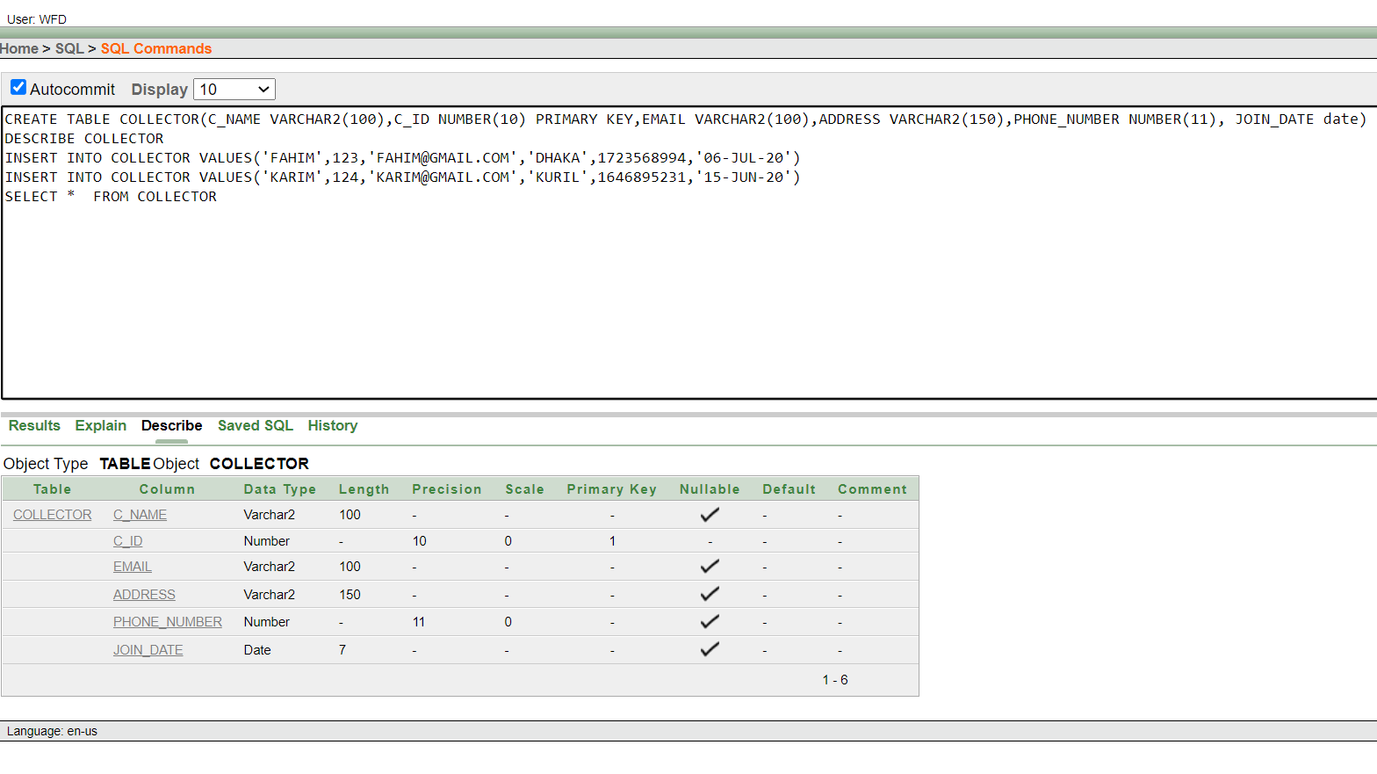

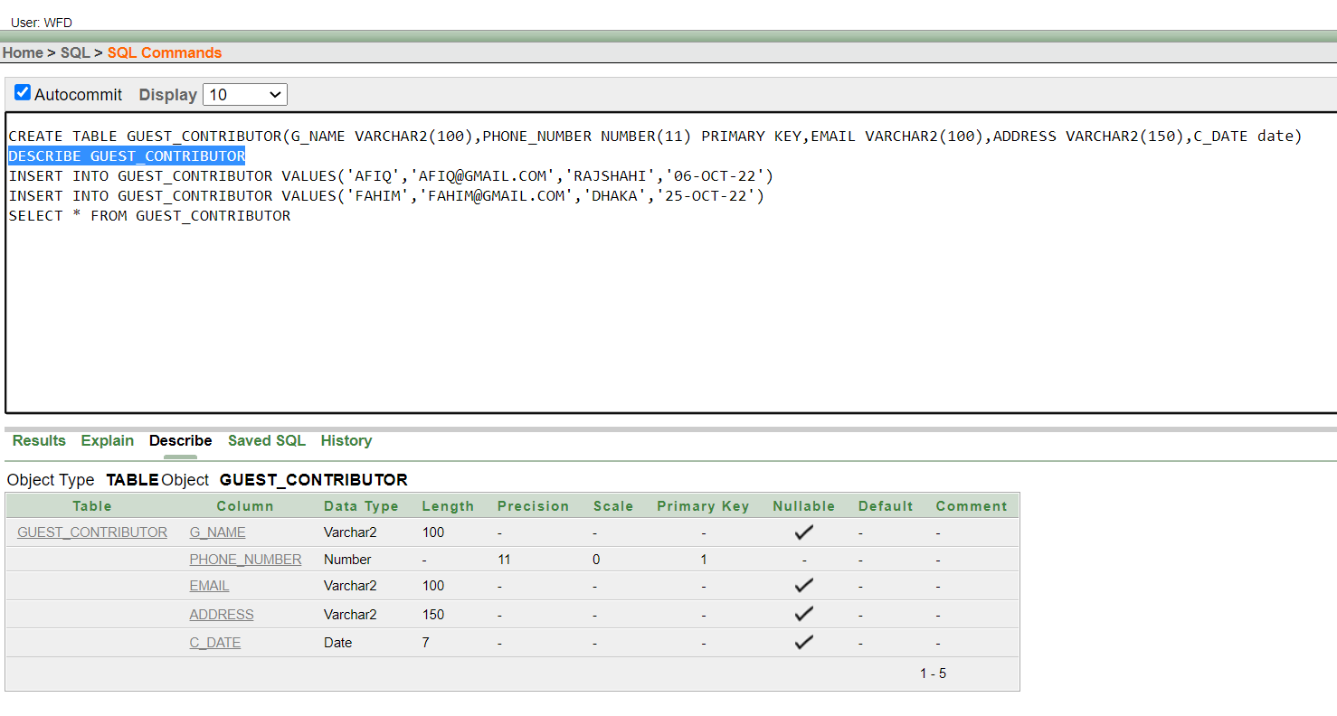

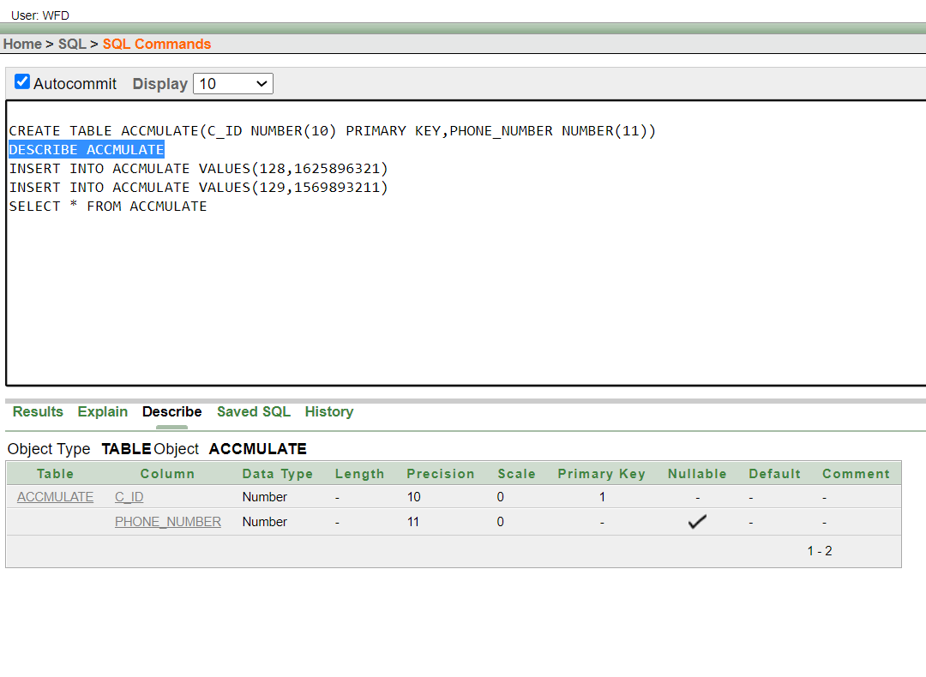

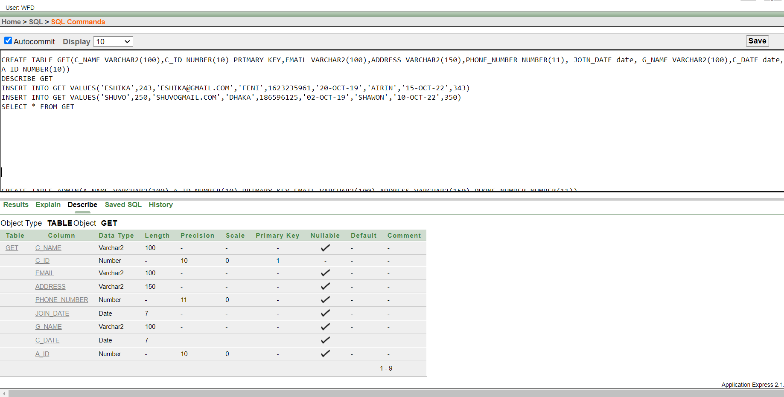

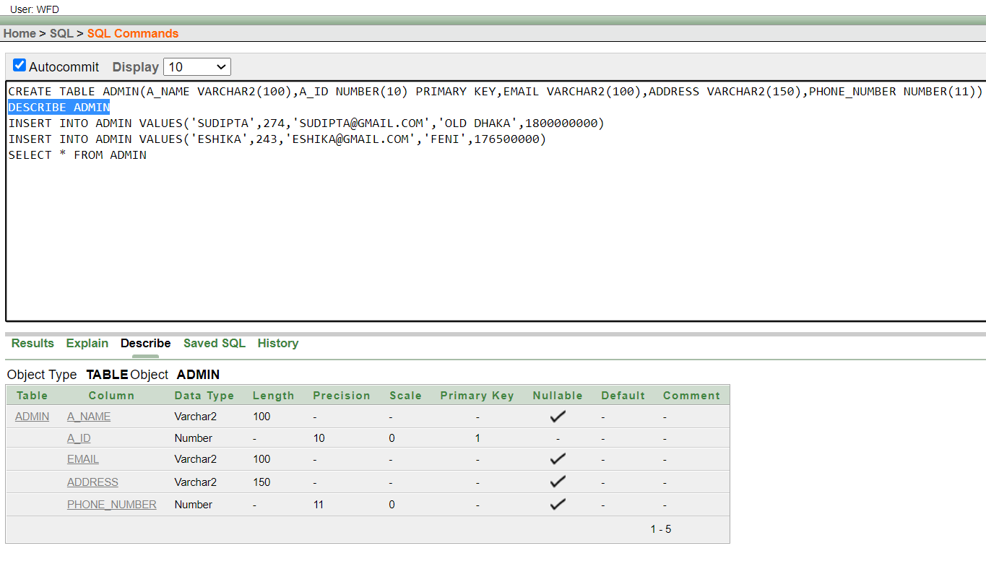

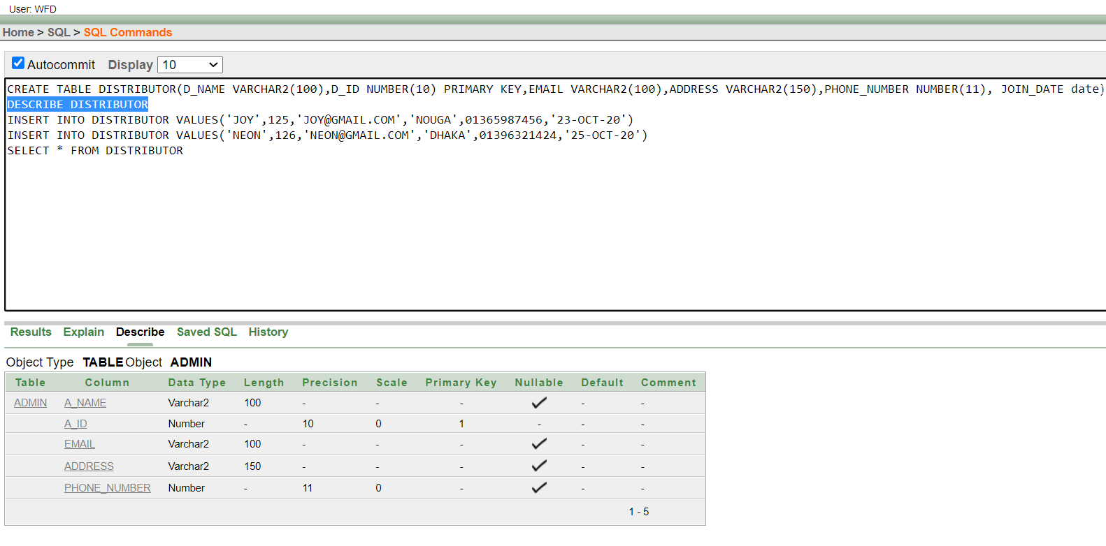

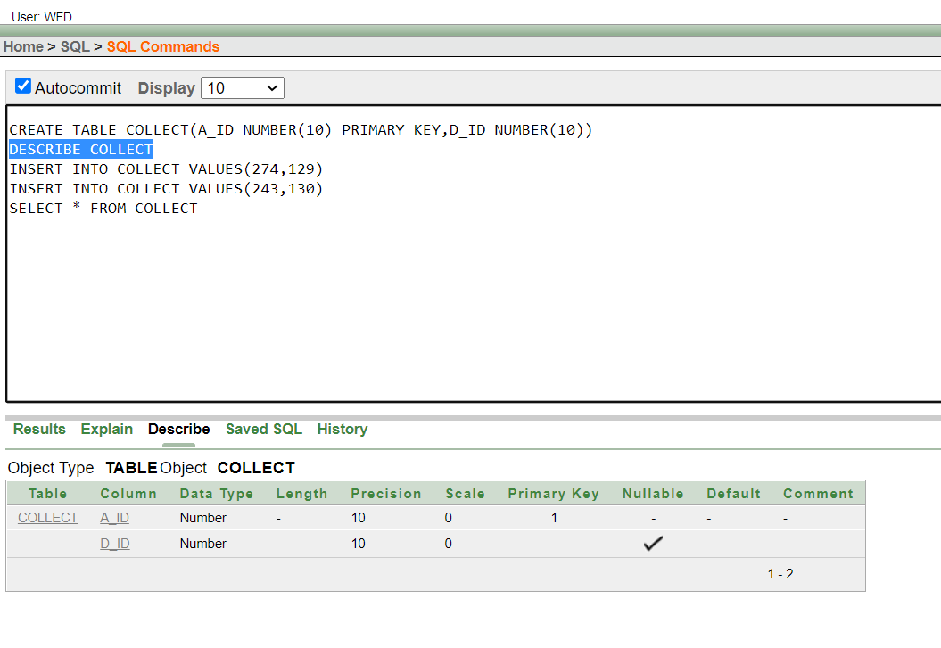
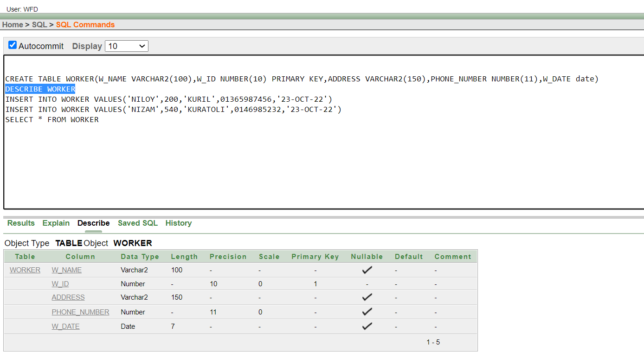

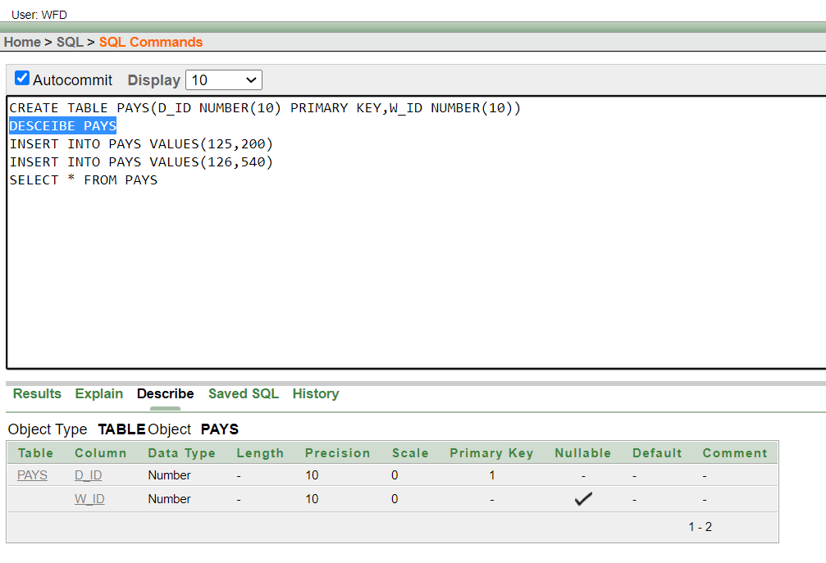

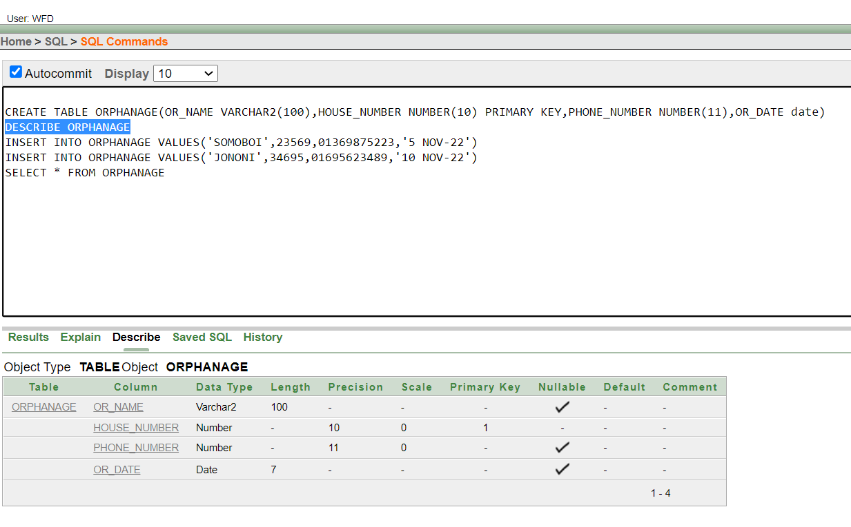

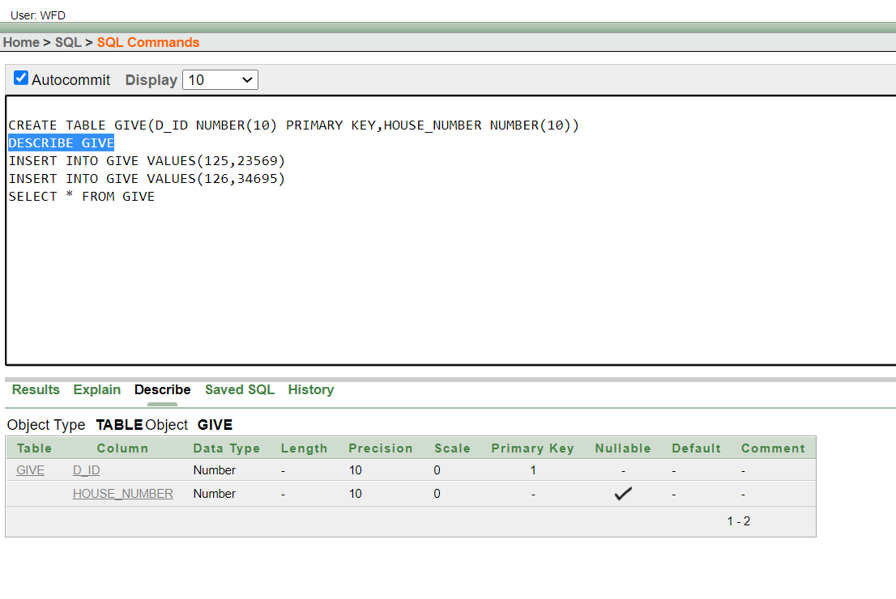
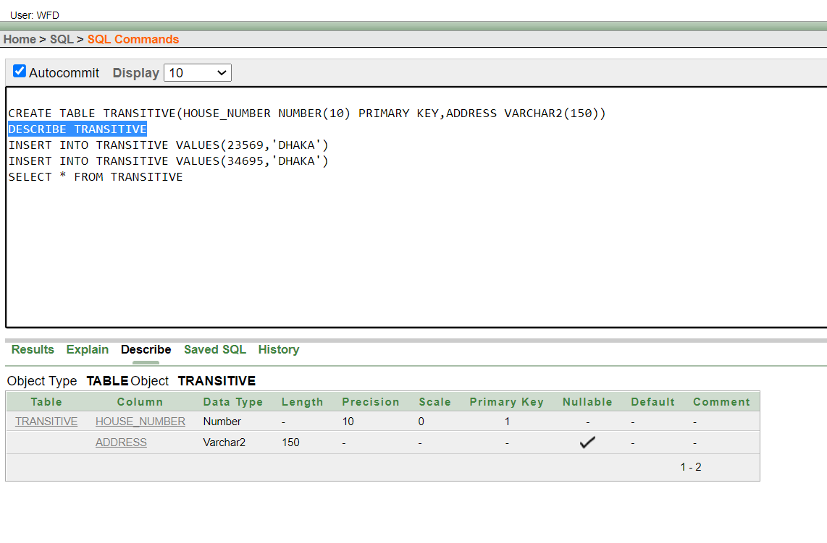

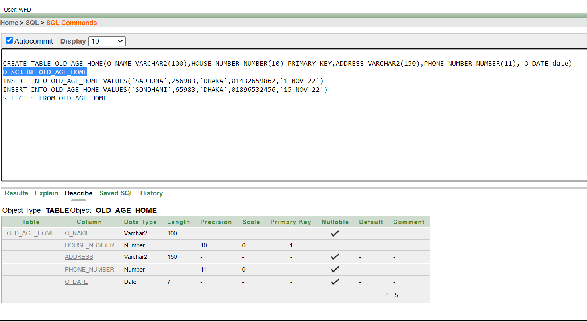

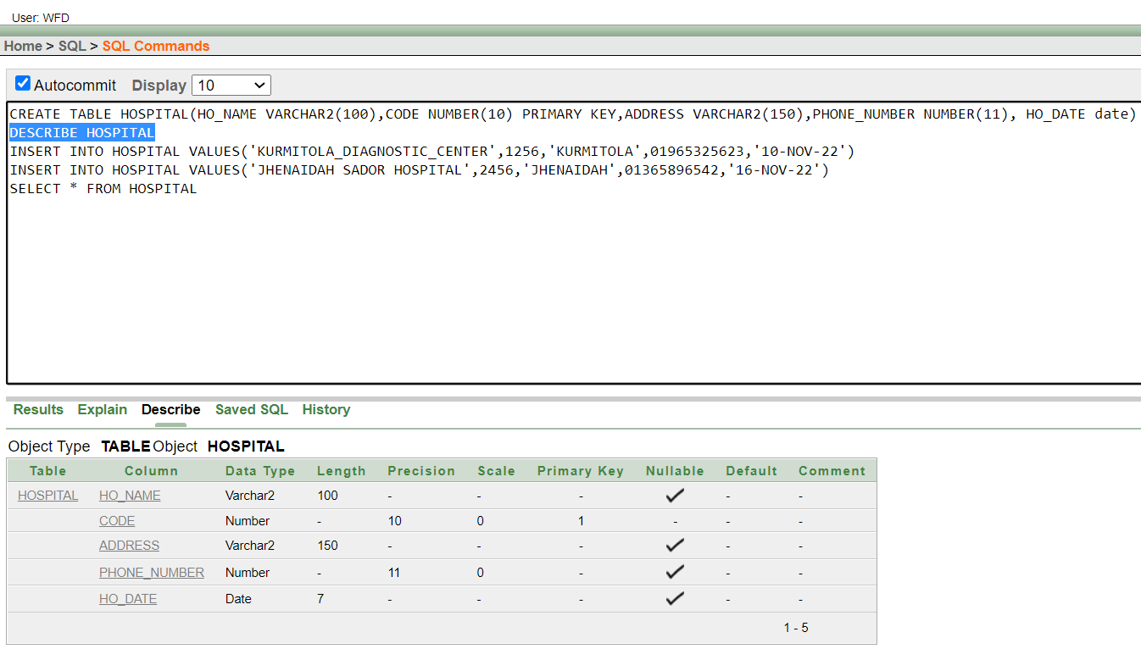

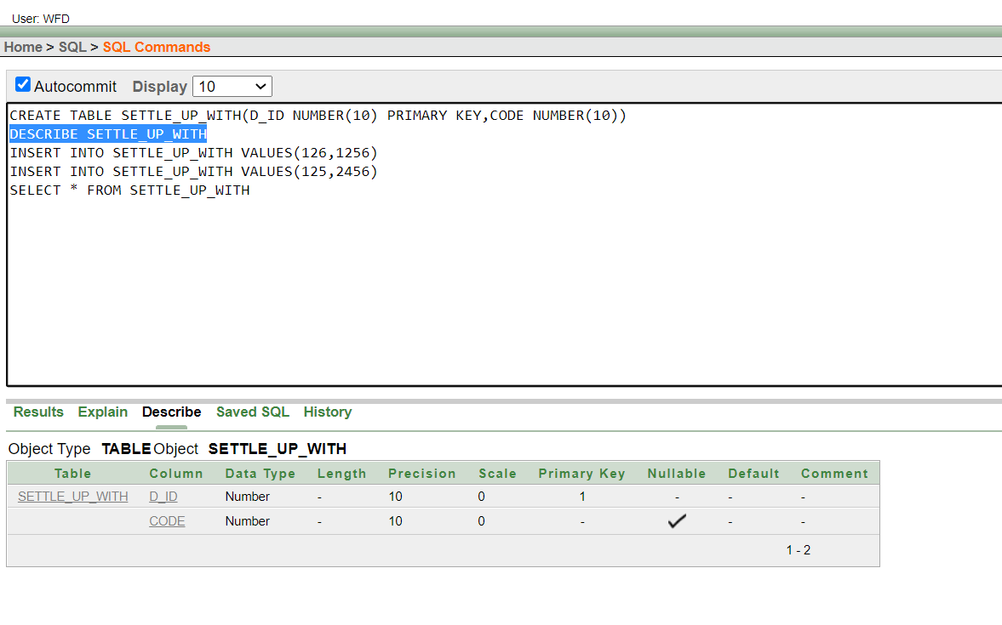

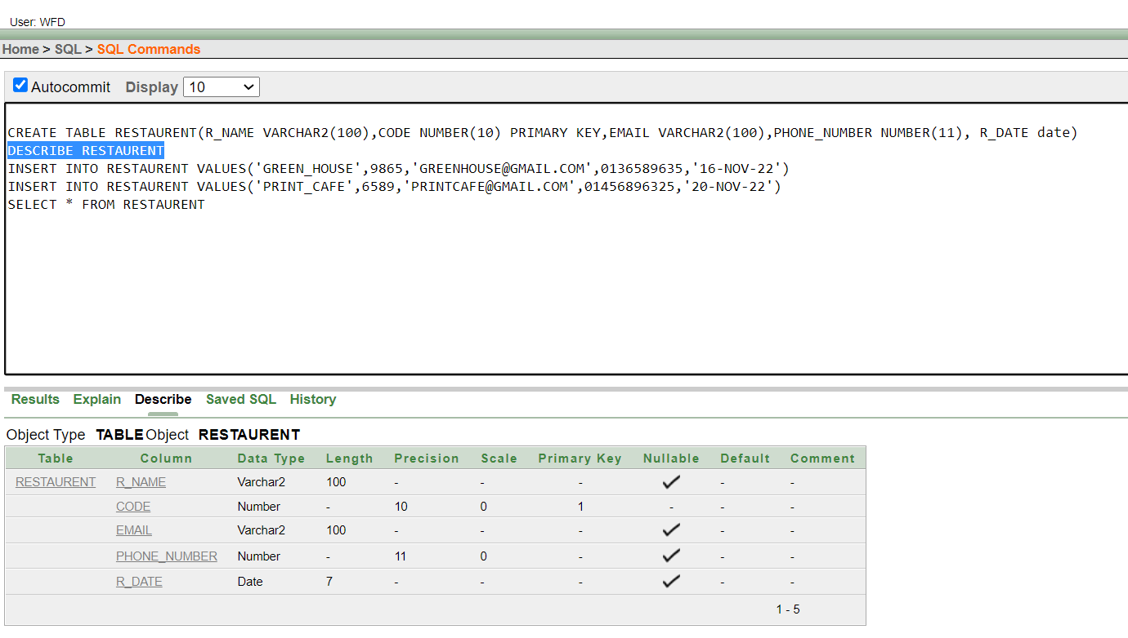

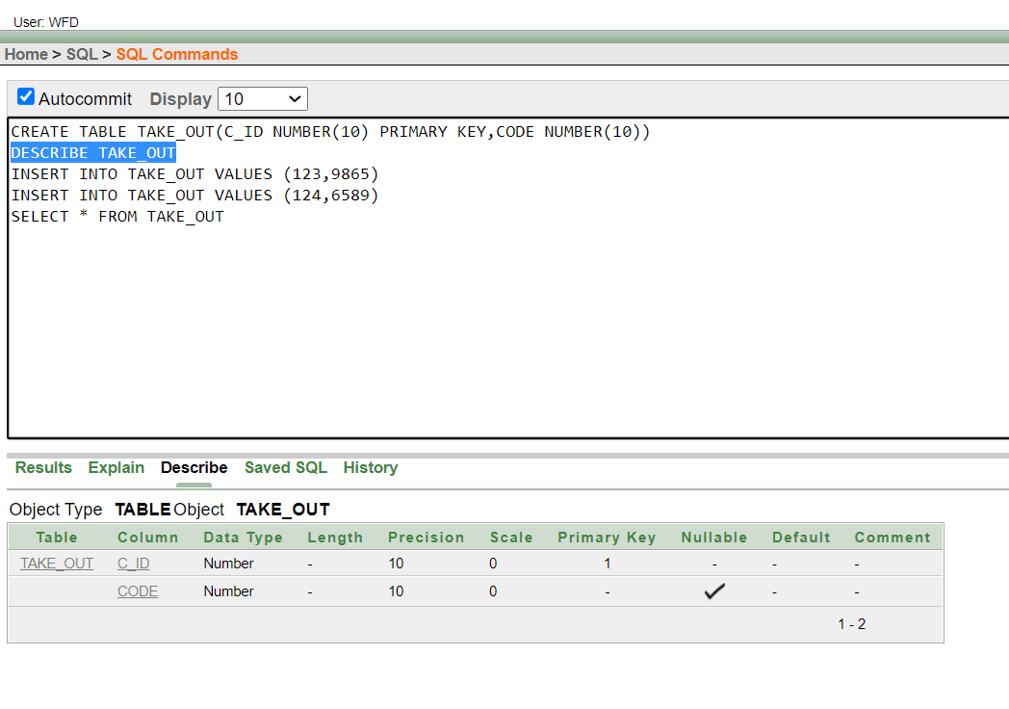

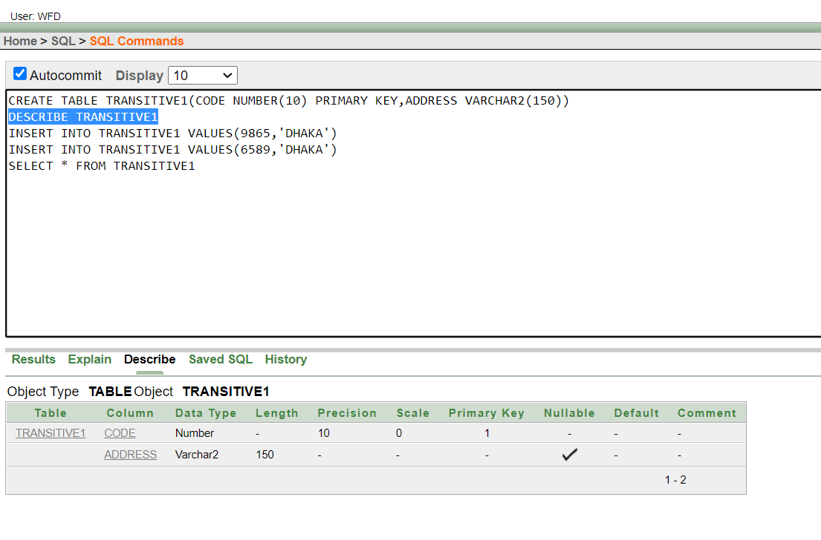

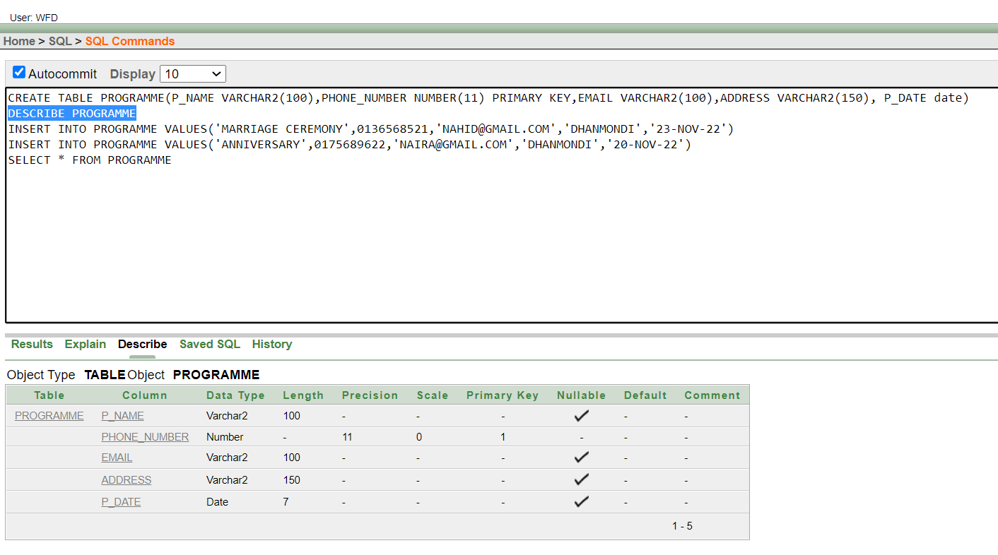

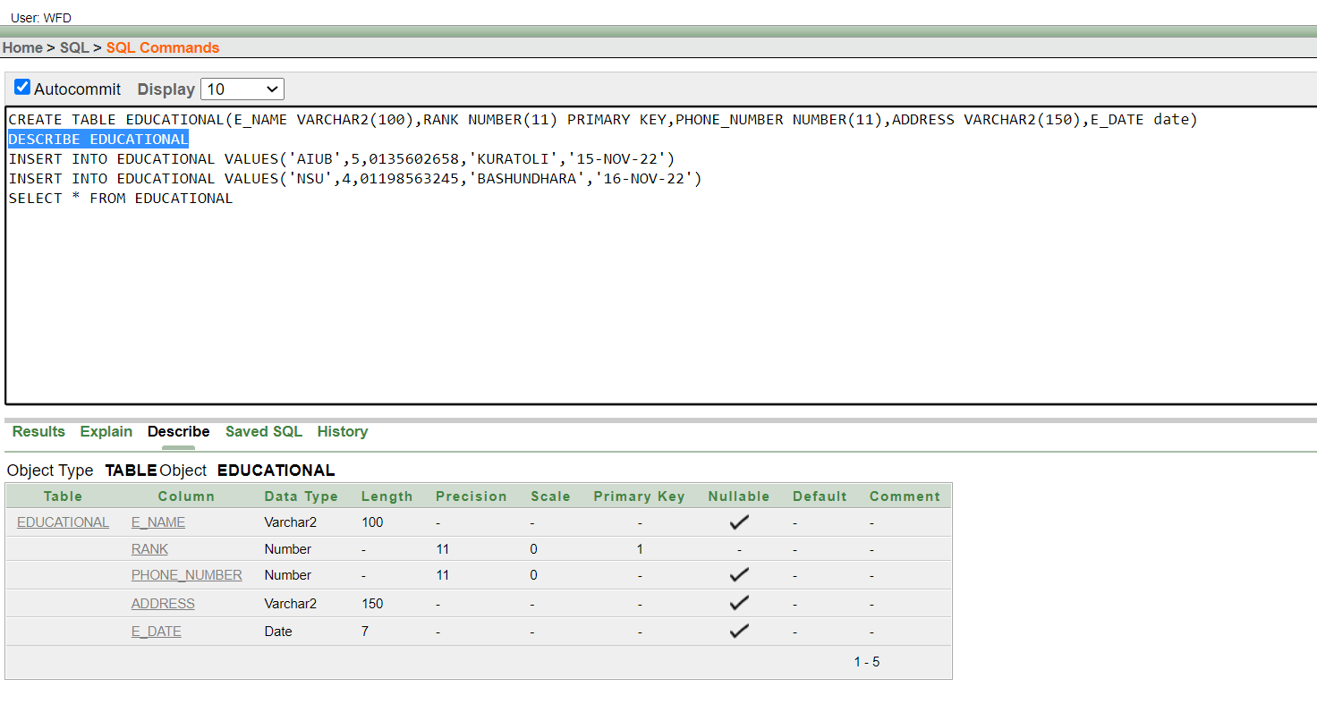

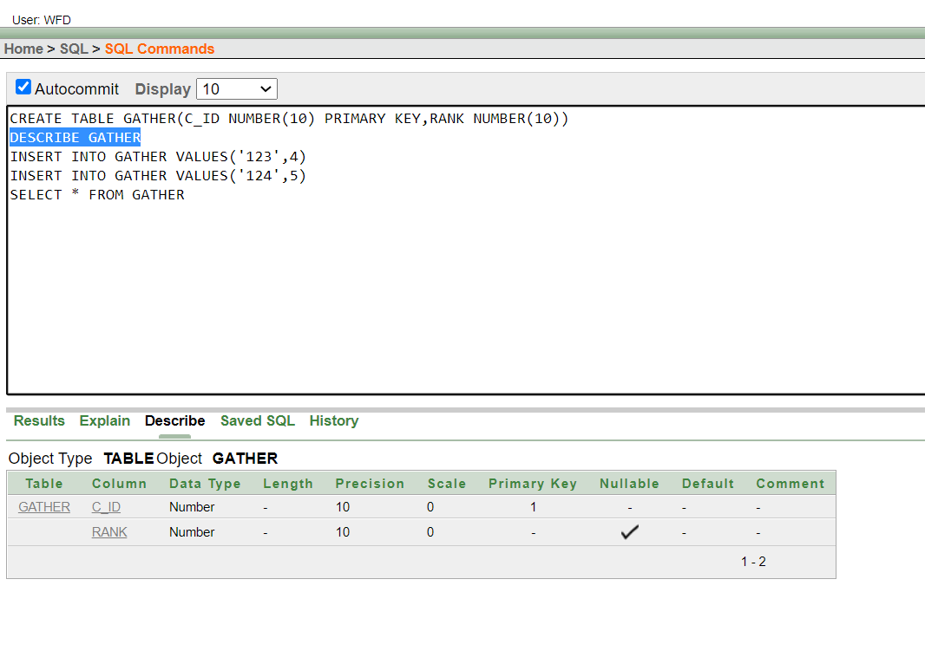
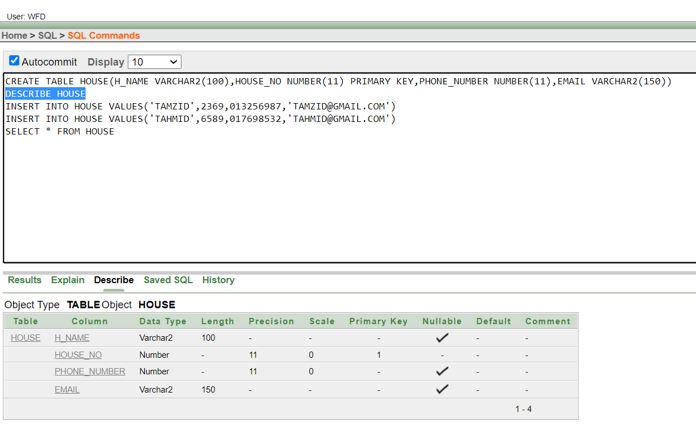

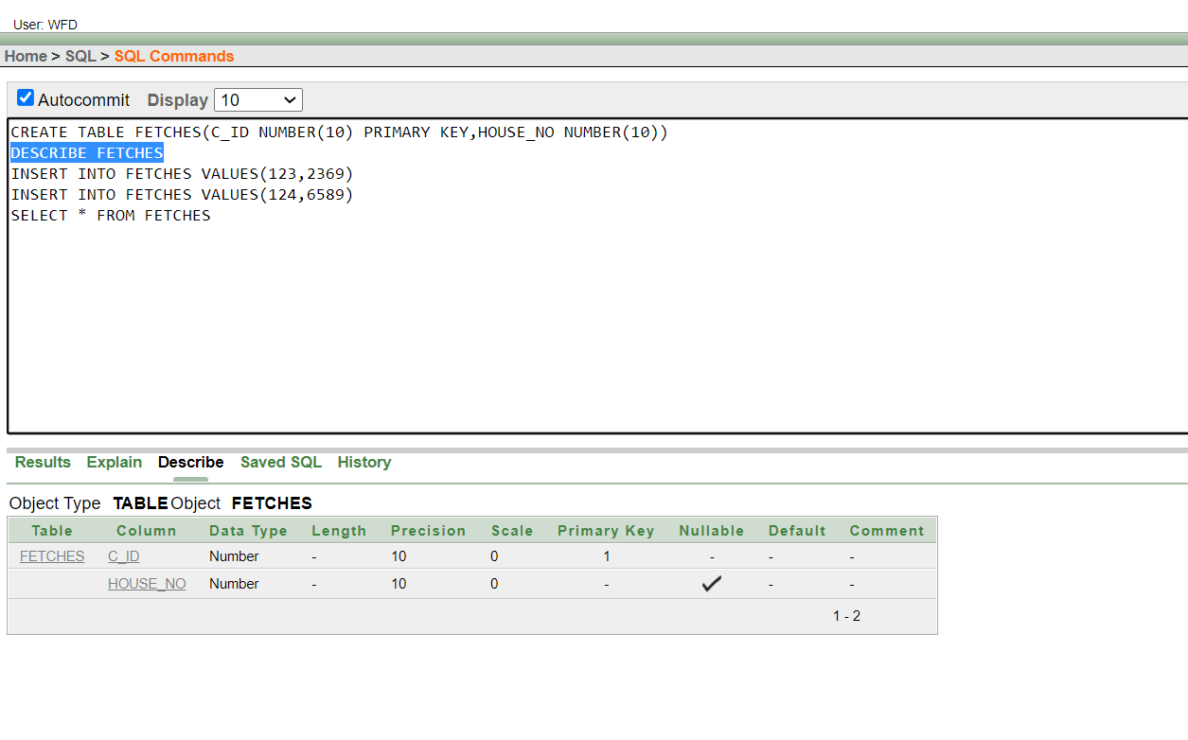

VALUE INSERT:
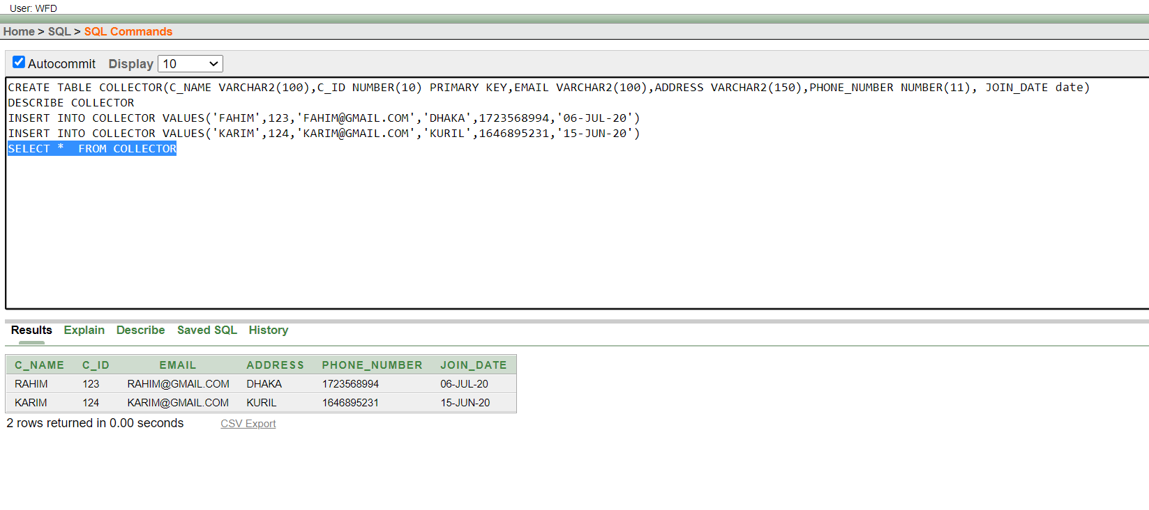

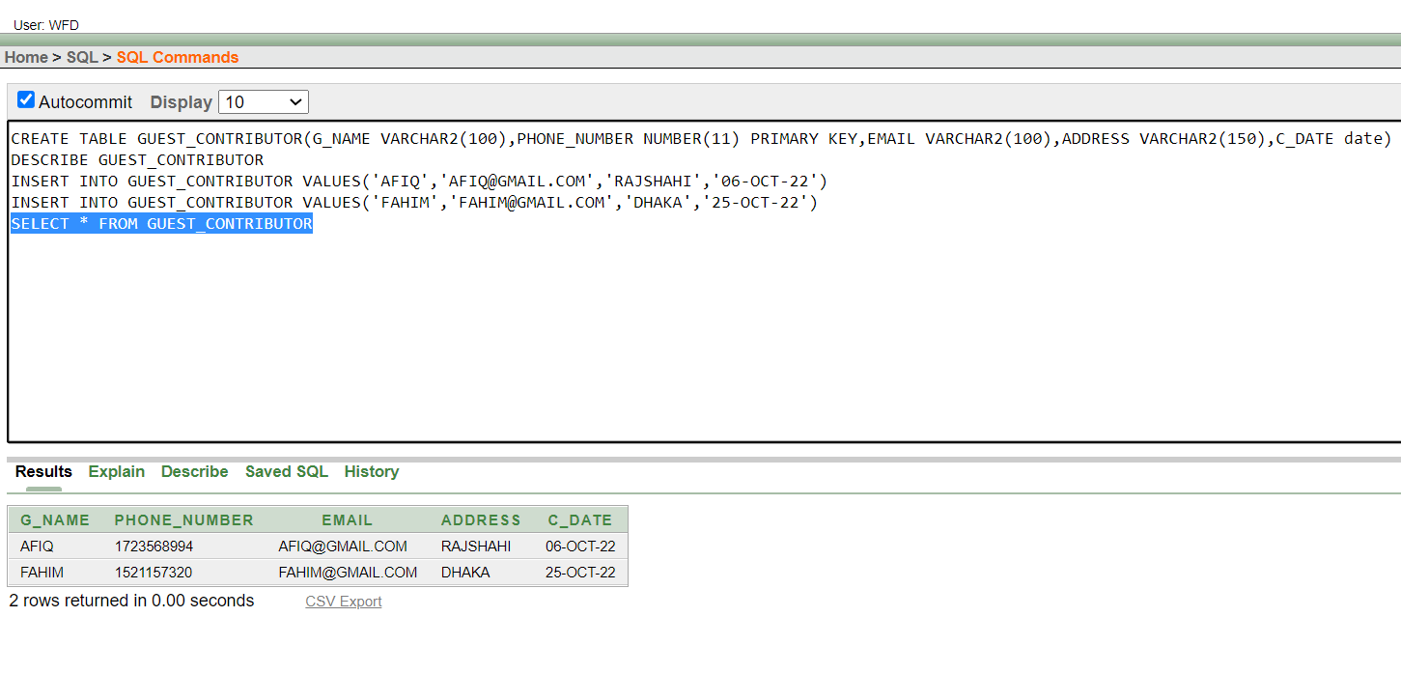

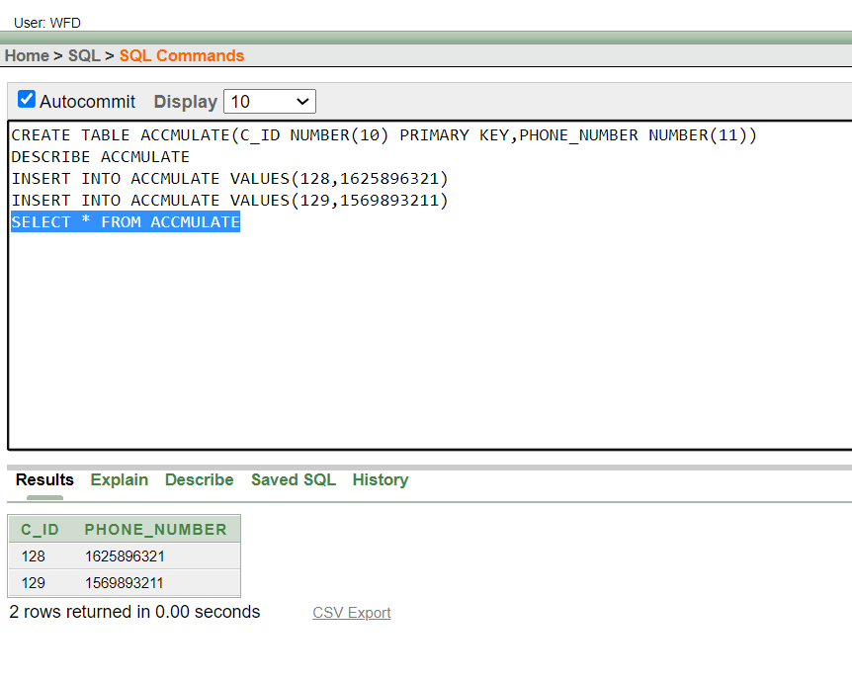

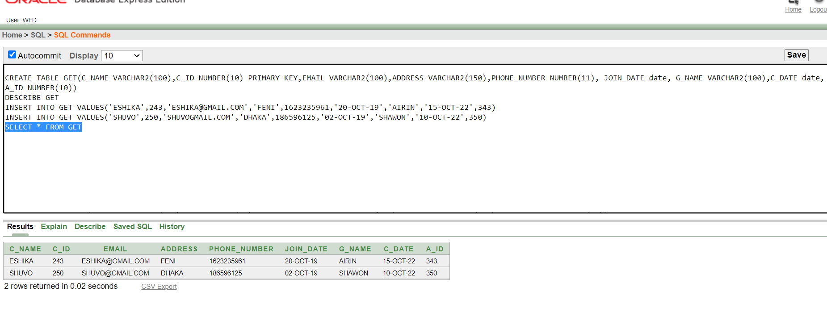

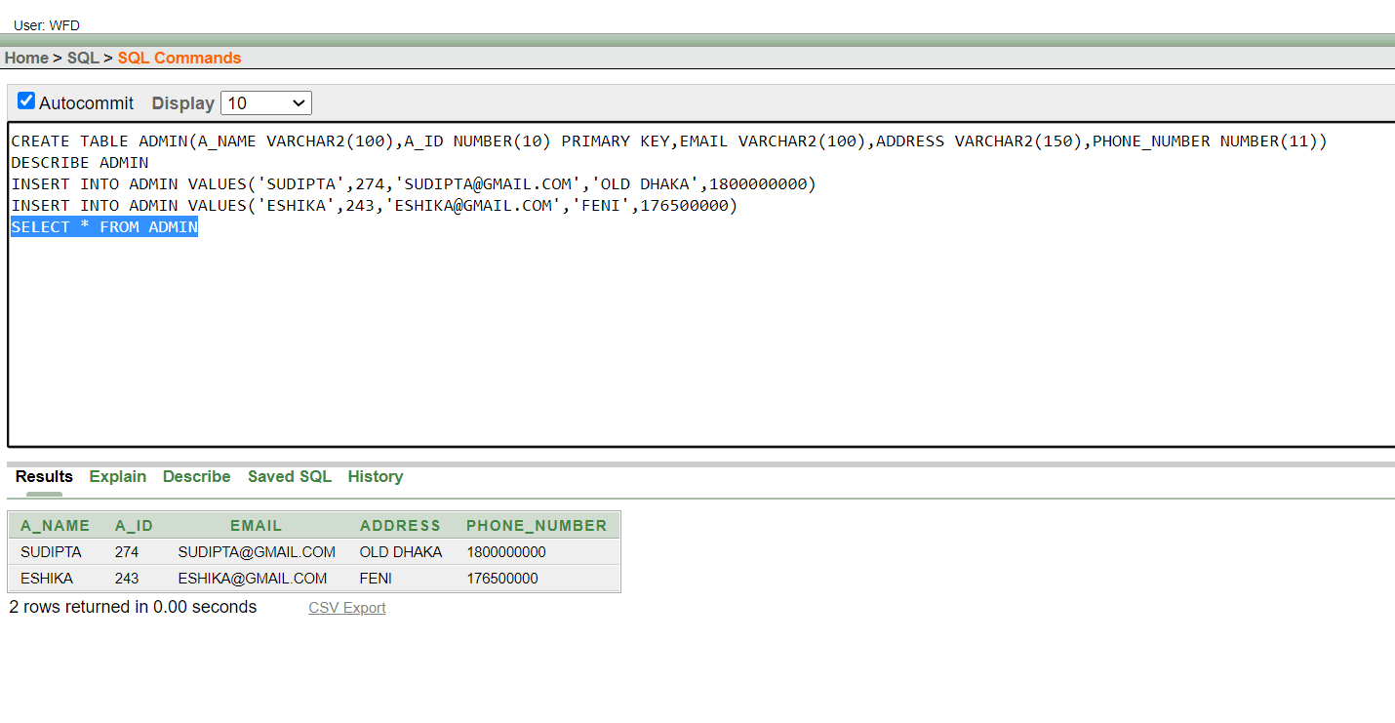

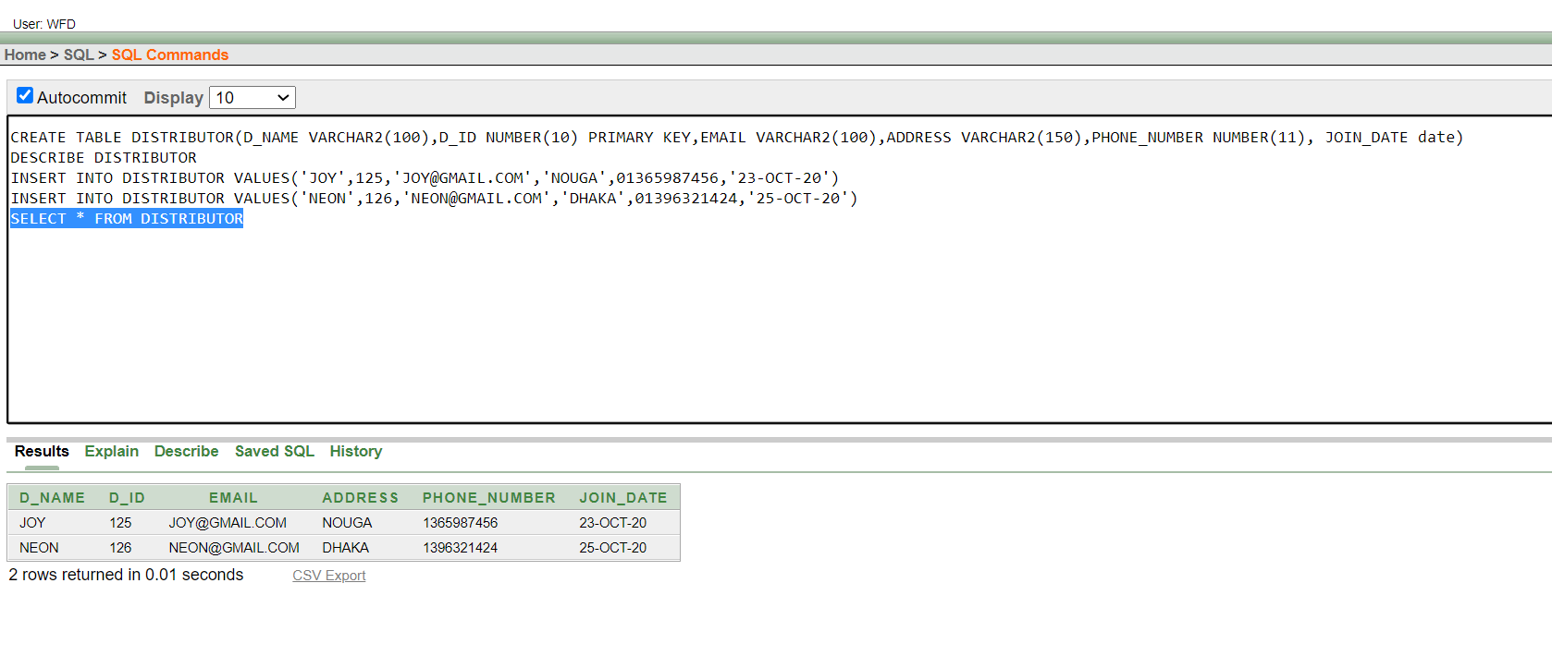

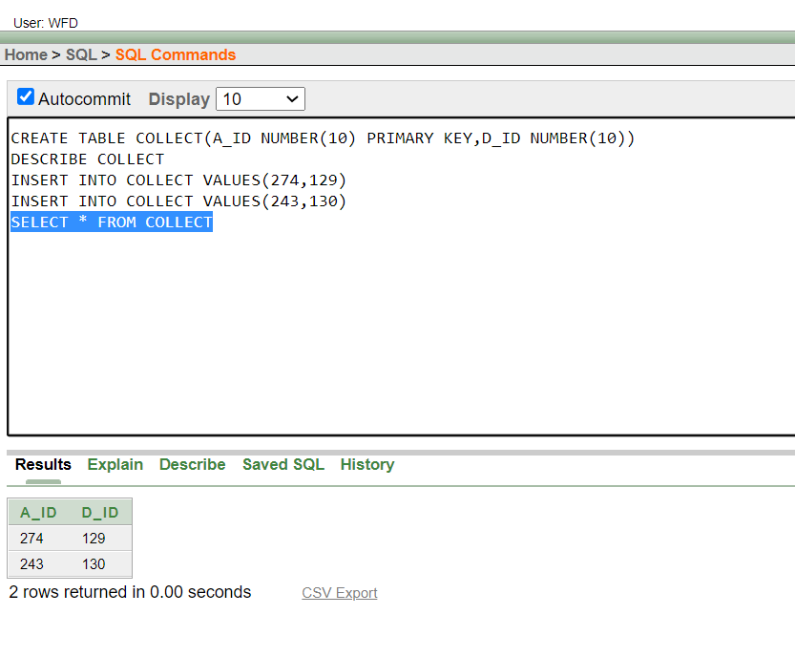

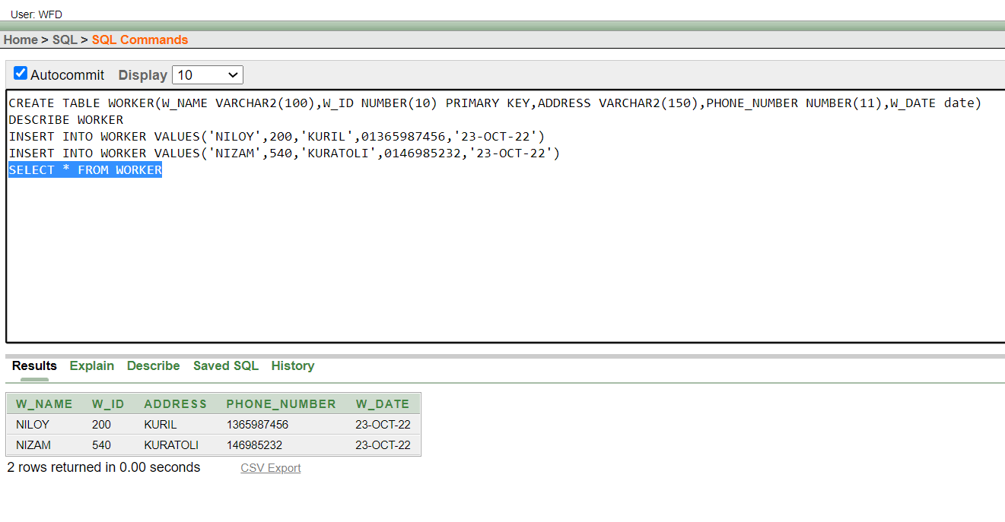

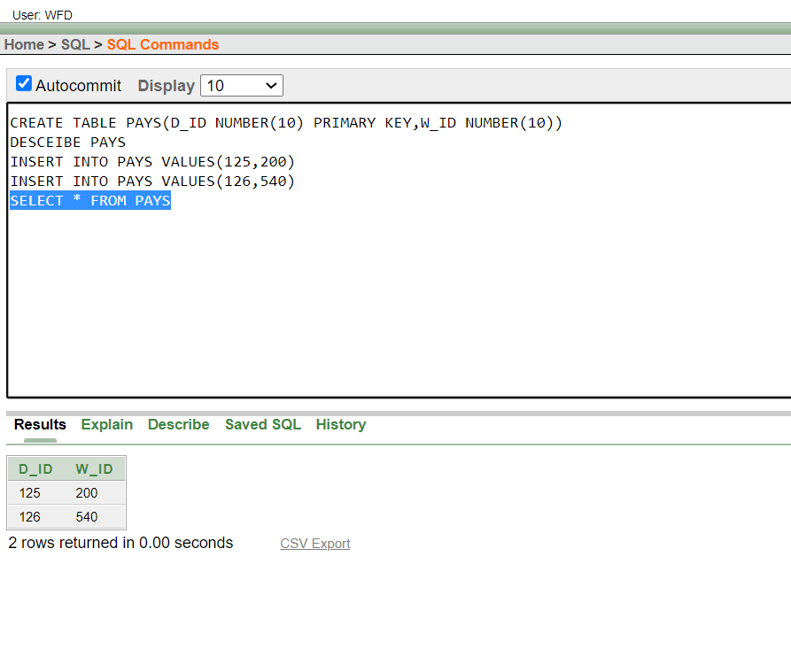

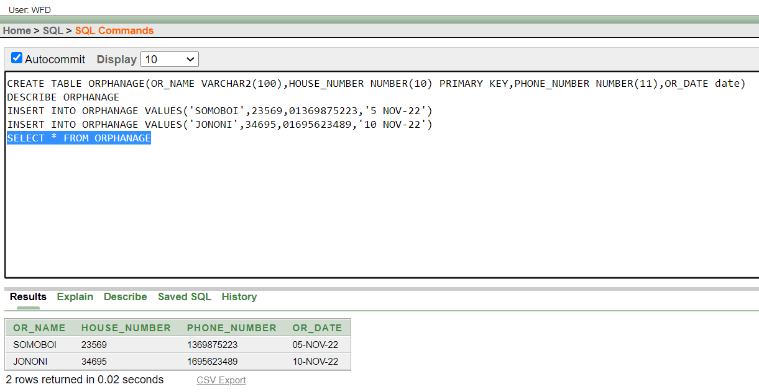
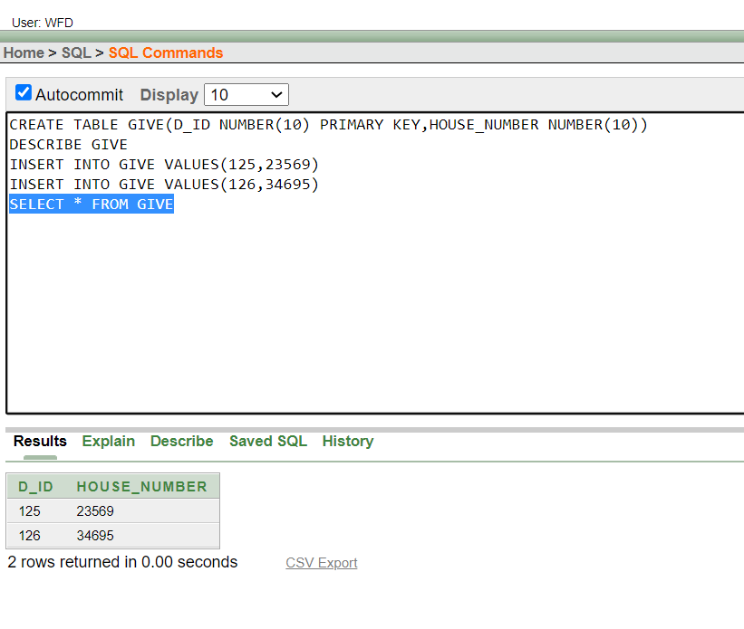

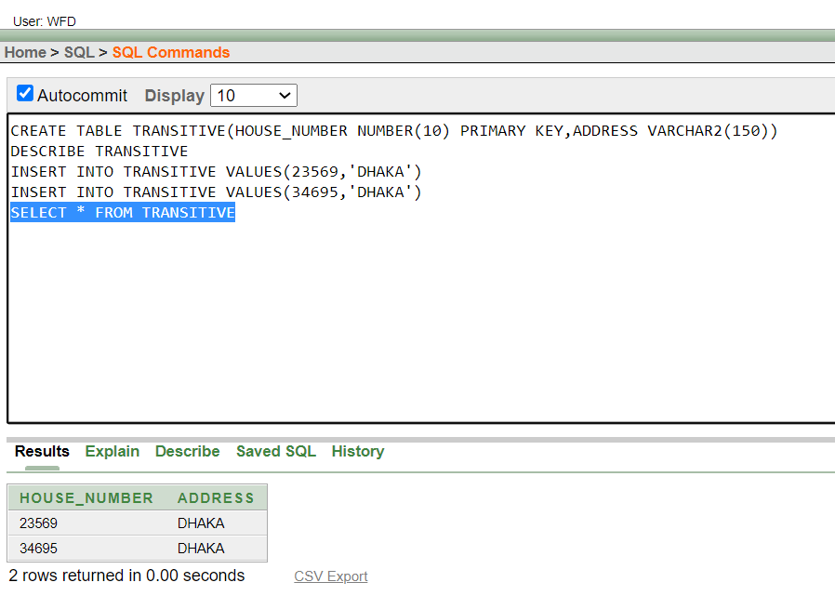

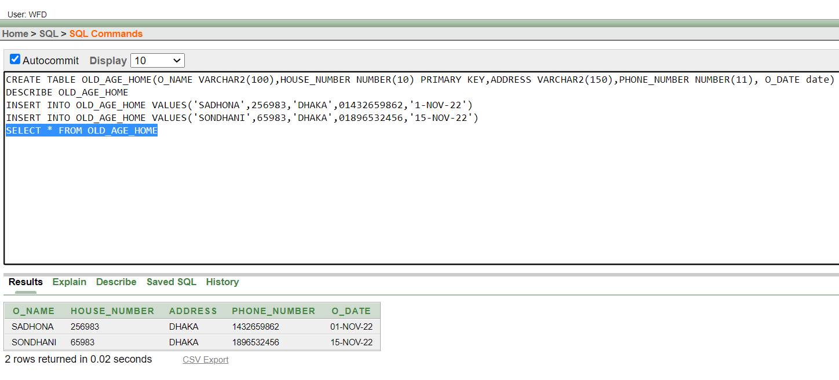

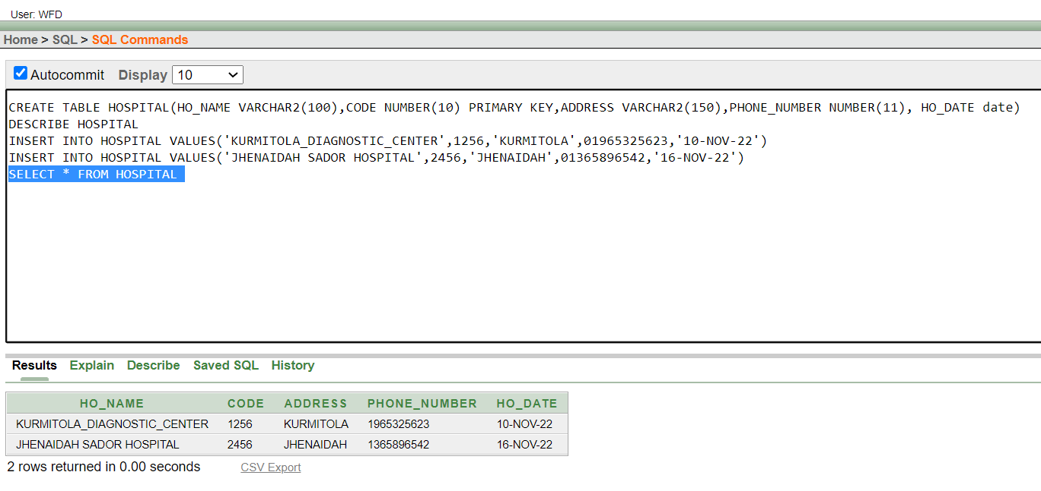

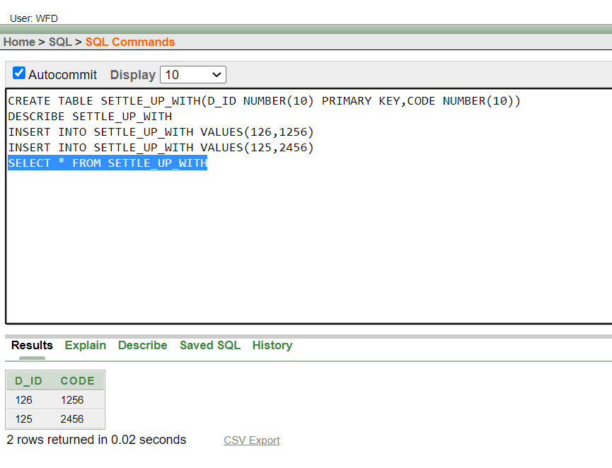

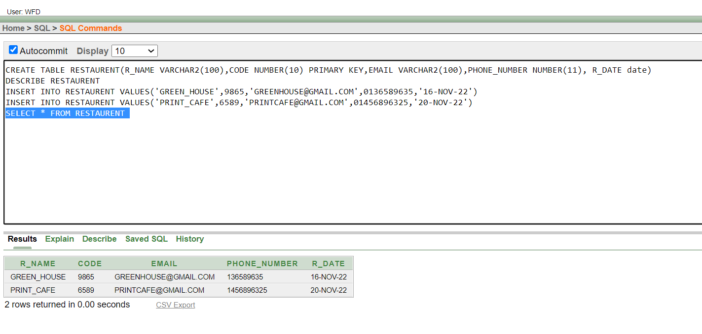
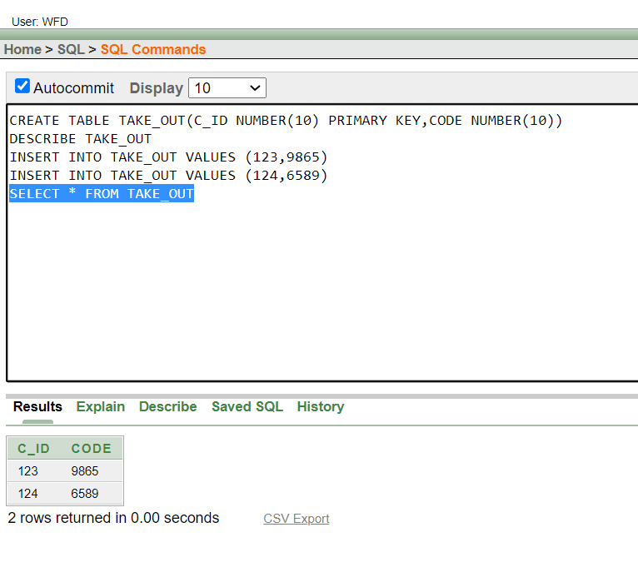

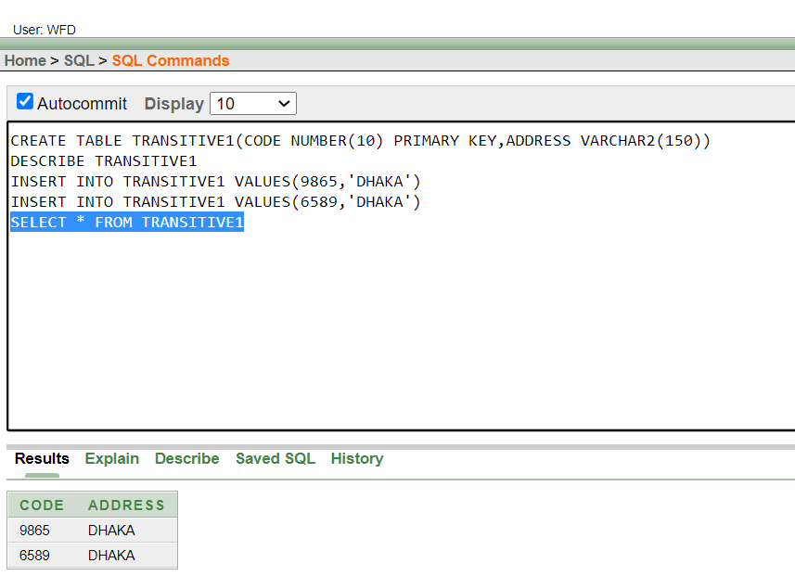

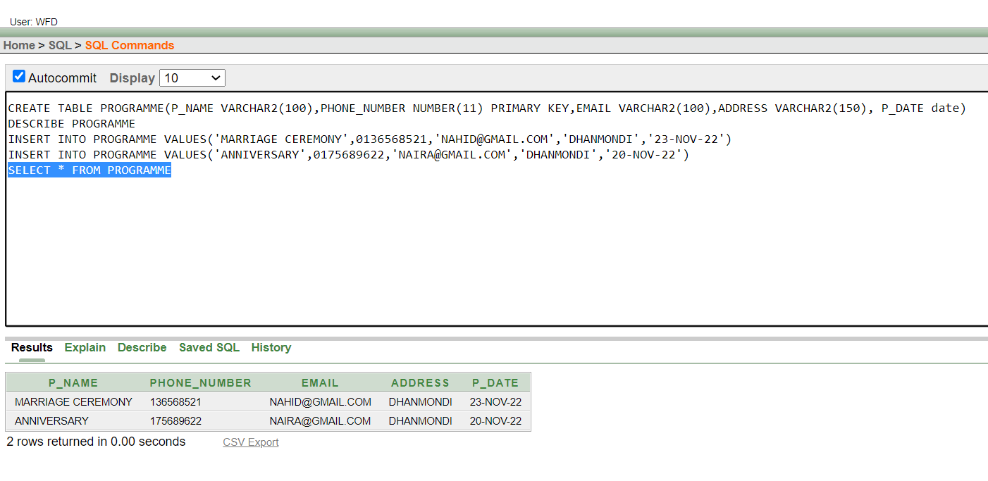

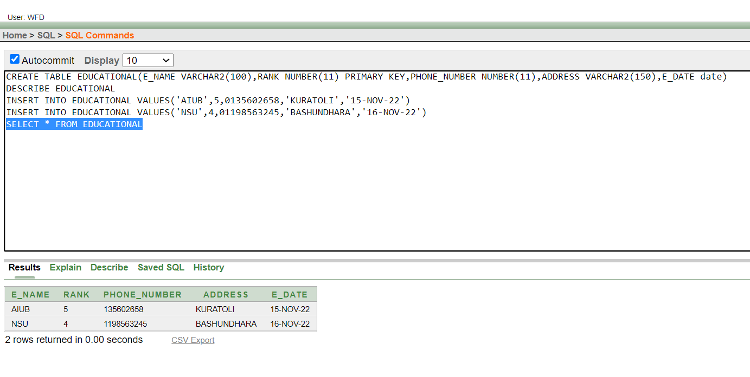

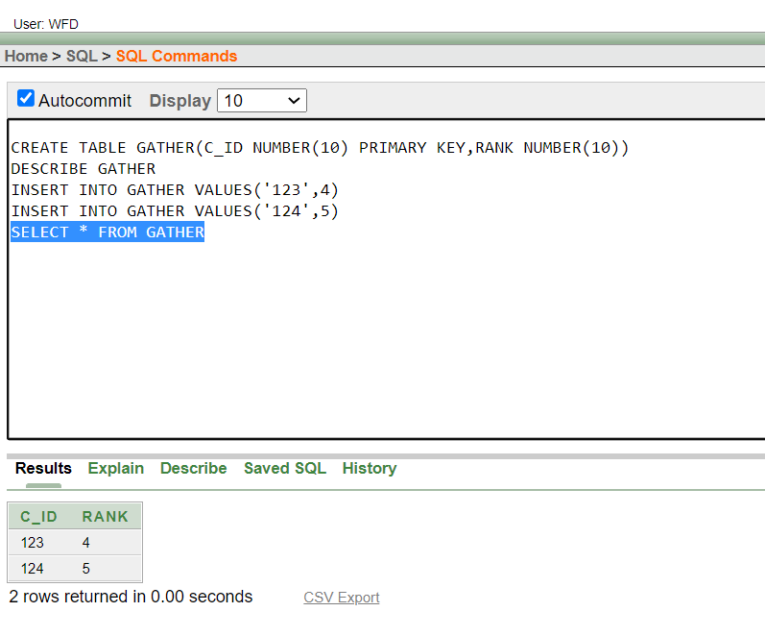
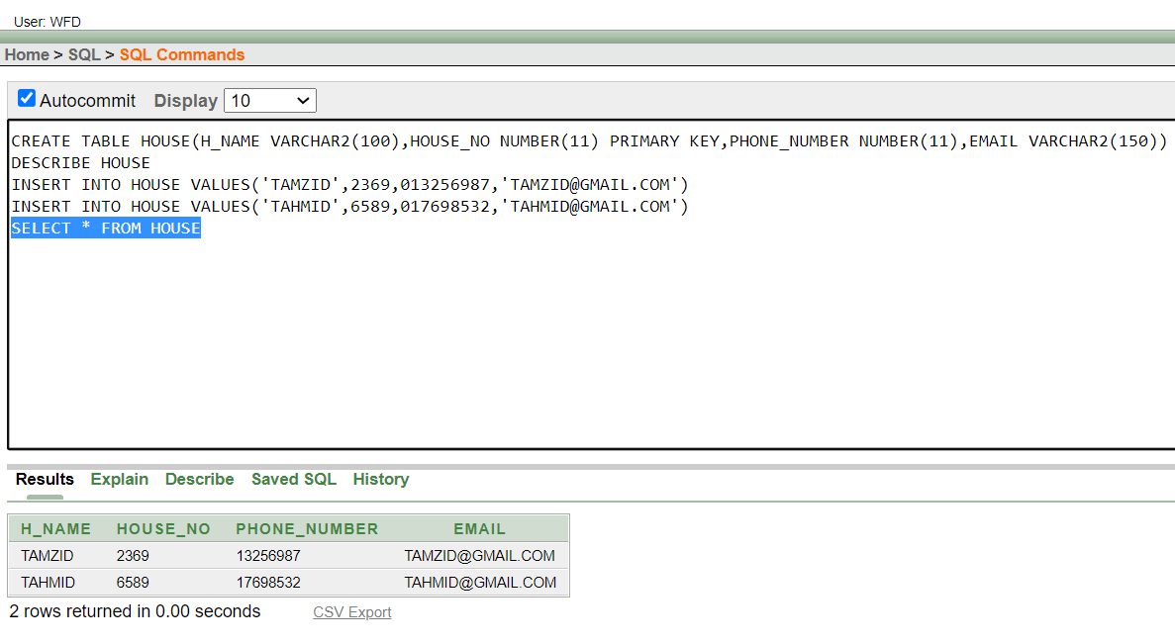

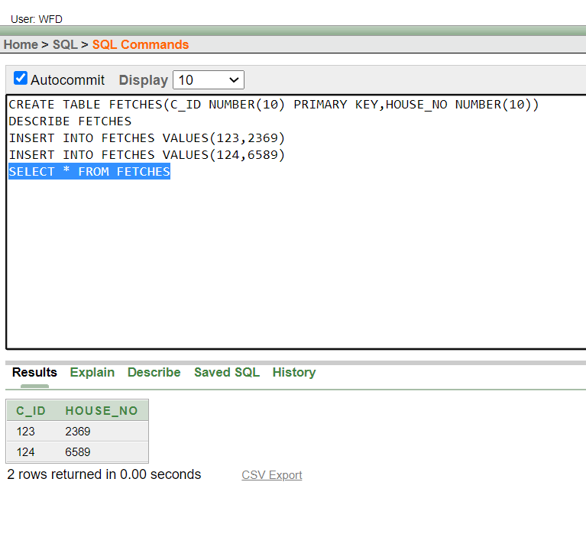

QUERY WRITING:
SUBQUERY
1. SHOW THE D_NAME, D_ID, EMAIL, PHONE_NUMBER WHERE JOIN_DATE IS GATHER THAN JOY?
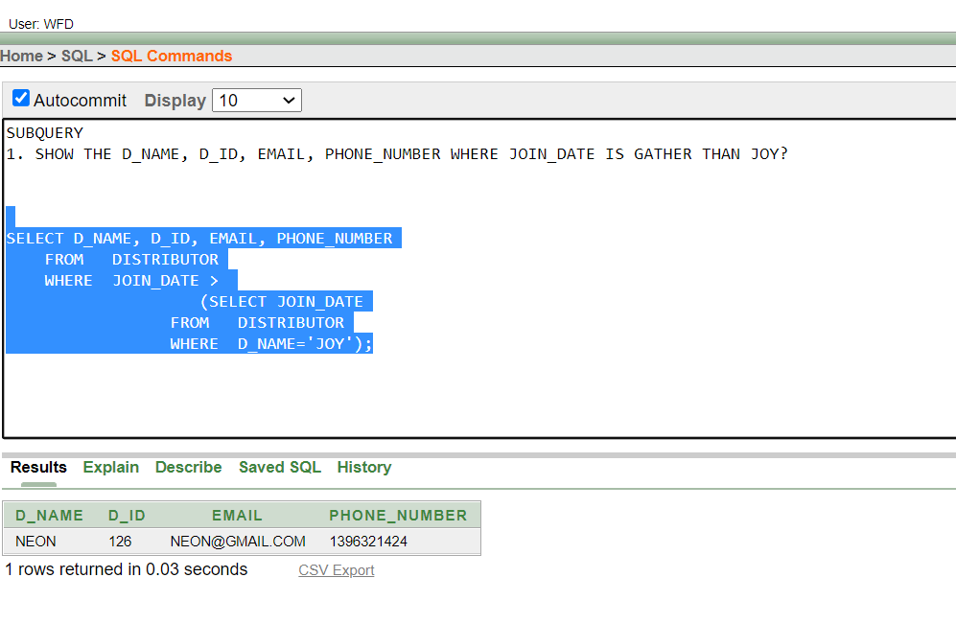
SINGLE ROW SUBQUERY
1. Find the c_name, c_id, adddress where address is equal to DHAKA and c_id is gather than 124?
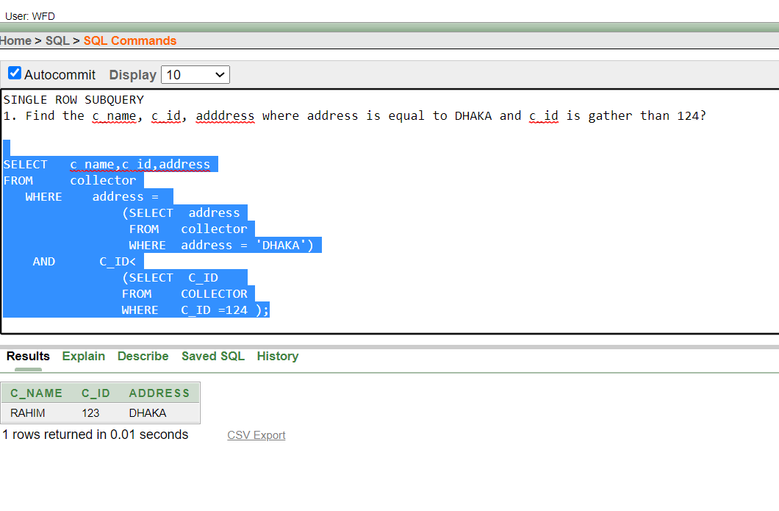
2.FIND THE A_NAME WHOSE ID IS GRATHER THAN THE GROUP WISSE MINIMUN SALARY
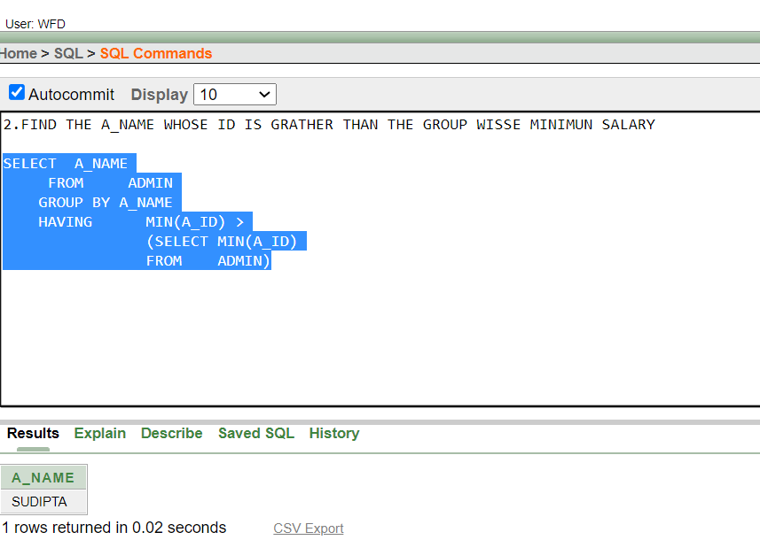
MULTIPLE ROW SUBQUERY
1. FIND THE R_NAME, CODE, PHONE_NUMBER,R_DATE WHERE R_DATE IS LESS THAN TODAY DATE?
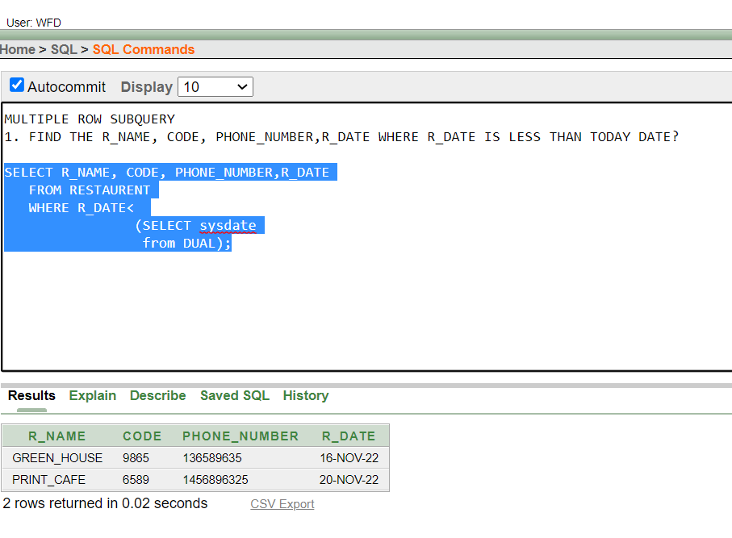
2.FIND THE E_NAME, PHONE_NUMBER WHICH VARSITY RANK IS LESS THAN THE VARSITY IN BASHUNDHARA AND ADDRESS NOT EQUAL TO BASHUNDHARA
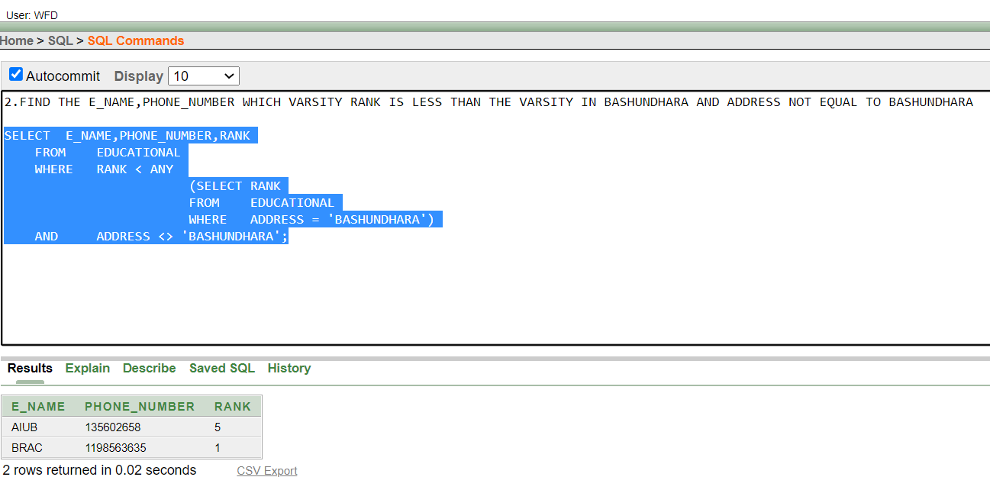

JOINING
EQUIJOIN:
1. DISPLAY ALL THE INFORMATION FROM ACCMULATE AND COLLECT TABLE?
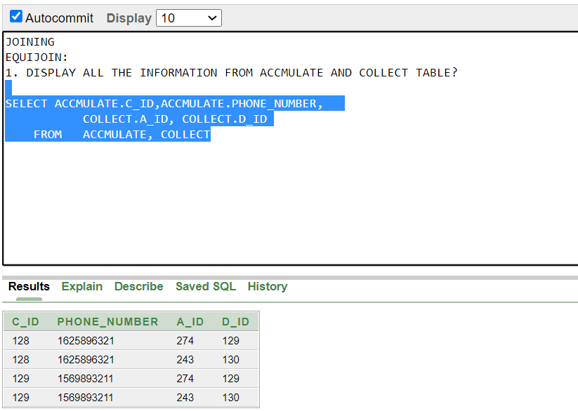
SELFJOIN:
2.GET ALL THE INFORMATION FROM ADMIN AND COLLECT WHERE A_ID IS SAME?
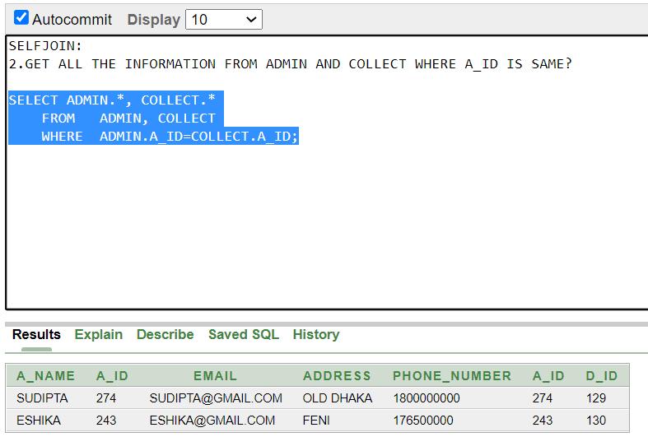
OUTERJOIN:
3.SHOW THE INFORMATION FROM EDUCATIONAL AND GATHER TABLE WHERE RANK ROW ARE NOT SAME
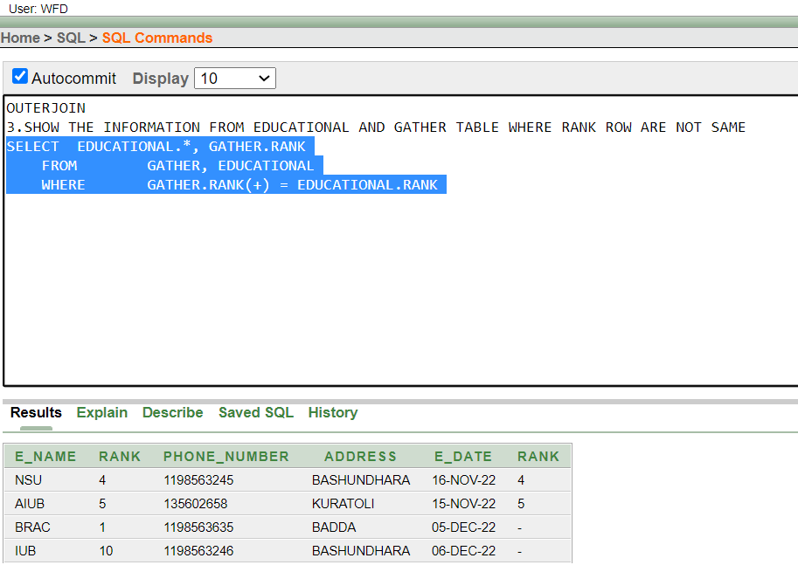

VIEW:
1. SHOW A VIEW FROM EDUCATIONAL TABLE
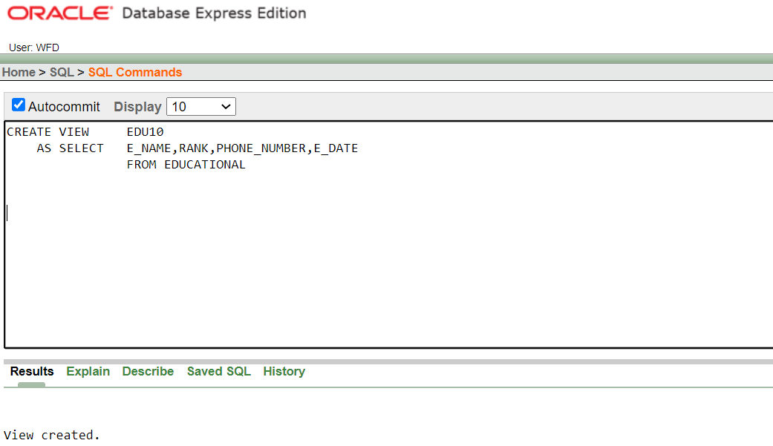
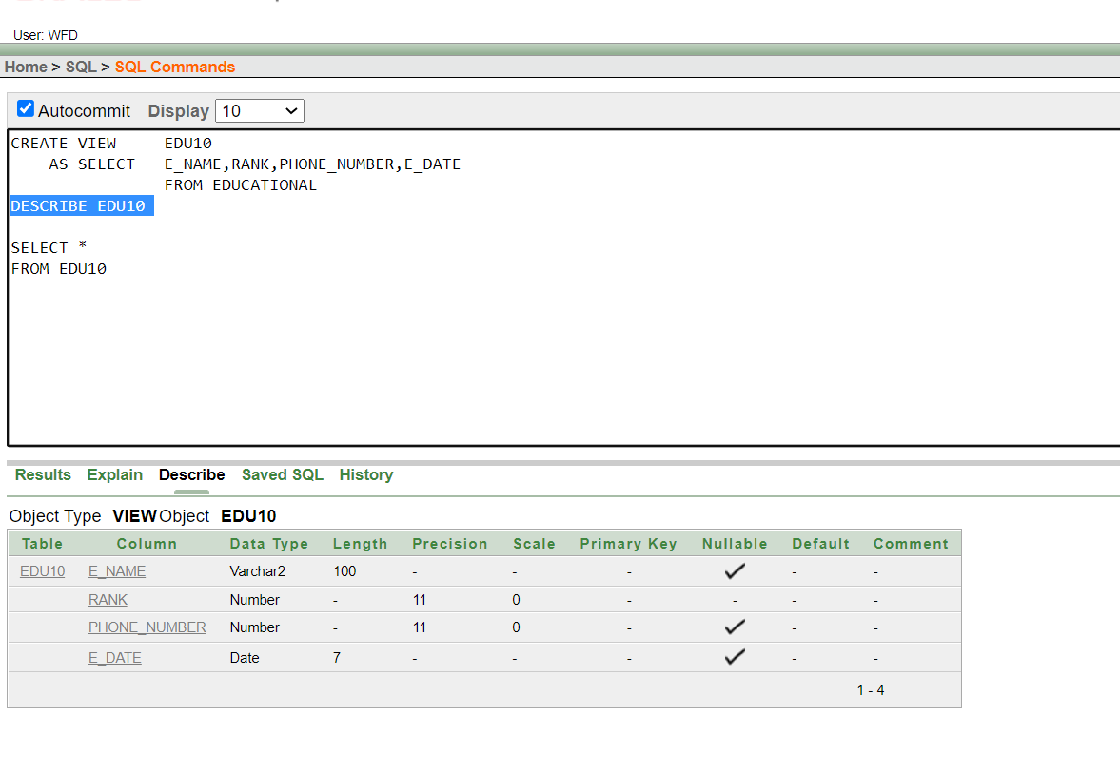

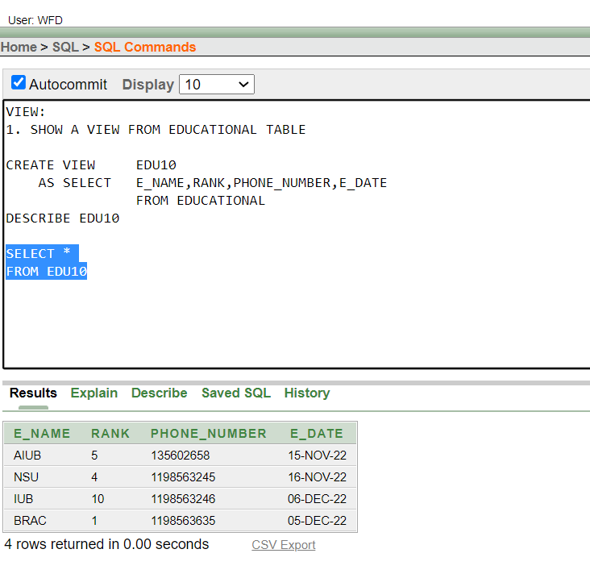

CONCLUSION:
We have shown all the queries to create the tables in 'Oracle 10g'. Also, we had shown the queries to insert the values and took their screen-shots. Here, we made 13 different relations among the entities. The normalization process has made our way easier.
FUTURE OF CONTAIN:
The goal of Waste Food Distribution System is claim up every classes of people’s hunger and reduce food waste. We eagerly wants to implement this idea in C# and in future we will works on it. We wants to spread out this project world wide.

